CSC438

(DATABASE DESIGN AND MANAGEMENT)

2 UNITS

DR. J.B. AGBOGUN

DEPARTMENT OF COMPUTER SCIENCE AND MATHEMATICS

FACULTY OF NATURAL SCIENCES AND ENVIRONMENTAL STUDIES

GODFREY OKOYE UNIVERSITY,

ENUGU.

Lesson 01: Introduction
Structure
1.0 Objectives
1.1 Introduction
1.2 Data Processing Vs. Data Management Systems
1.3 File Oriented Approach
1.4 Database Oriented Approach to Data Management
1.5 Characteristics of Database
1.6 Advantages and Disadvantages of a DBMS
1.7 Instances and Schemas
1.8 Data Models
1.9 Database Languages
1.9 Data Dictionary
1.11 Database Administrators and Database Users
1.12 DBMS Architecture and Data Independence
1.13 Types of Database System
1.14 Summary
1.15 keywords
1.16 Self Assessment Questions (SAQ)
1.17 References/Suggested Readings

1.0 Objectives
At the end of this chapter the reader will be able to:
- Distinguish between data and information and Knowledge
- Distinguish between file processing system and DBMS
- Describe DBMS its advantages and disadvantages
- Describe Database users including data base administrator
- Describe data models, schemas and instances.
- Describe DBMS Architecture & Data Independence
- Describe Data Languages

1.1 Introduction
A database-management system (DBMS) is a collection of interrelated data and a set of programs to access those data. This is a collection of related data with an implicit meaning and hence is a database. The collection of data, usually referred to as the database, contains information relevant to an enterprise. The primary goal of a DBMS is to provide a way to store and retrieve database information that is both convenient and efficient. By data, we mean known facts that can be recorded and that have implicit meaning. For example, consider the names, telephone numbers, and addresses of the people you know. You may have recorded this data in an indexed address book, or you may have stored it on a diskette, using a personal computer and software such as DBASE IV or V, Microsoft ACCESS, or EXCEL.
A datum – a unit of data – is a symbol or a set of symbols which is used to represent something. This relationship between symbols and what they represent is the essence of what we mean by information. Hence, information is interpreted data – data supplied with semantics. Knowledge refers to the practical use of information. While information can be transported, stored or shared without many difficulties the same cannot be said about knowledge. Knowledge necessarily involves a personal experience. Referring back to the scientific experiment, a third person reading the results will have information about it, while the person who conducted the experiment personally will have knowledge about it.
Database systems are designed to manage large bodies of information. Management of data involves both defining structures for storage of information and providing mechanisms for the manipulation of information. In addition, the database system must ensure the safety of the information stored, despite system crashes or attempts at unauthorized access. If data are to be shared among several users, the system must avoid possible anomalous results.
Because information is so important in most organizations, computer scientists have developed a large body of concepts and techniques for managing data. These concepts and technique form the focus of this book. This chapter briefly introduces the principles of database systems.
1.2 Data Processing Vs. Data Management Systems
Although Data Processing and Data Management Systems both refer to functions that take raw data and transform it into usable information, the usage of the terms is very different.
Data Processing is the term generally used to describe what was done by large mainframe computers from the late 1940's until the early 1980's (and which continues to be done in most large organizations to a greater or lesser extent even today): large volumes of raw transaction data fed into programs that update a master file, with fixed-format reports written to paper.
The term Data Management Systems refers to an expansion of this concept, where the raw data, previously copied manually from paper to punched cards, and later into data-entry terminals, is now fed into the system from a variety of sources, including ATMs and direct customer entry through the Internet. The master file concept has been largely displaced by database management systems, and static reporting replaced or augmented by ad-hoc reporting and direct inquiry, including downloading of data by customers. The ubiquity of the Internet and the Personal Computer has been the driving force in the transformation of Data Processing to the more global concept of Data Management Systems.
1.3 File Oriented Approach
The earliest business computer systems were used to process business records and produce information. They were generally faster and more accurate than equivalent manual systems. These systems stored groups of records in separate files, and so they were called file processing systems. In a typical file processing systems, each department has its own files, designed specifically for those applications. The department itself works with the data processing staff, sets policies or standards for the format and maintenance of its files.
Programs are dependent on the files and vice-versa; that is, when the physical format of the file is changed, the program has also to be changed. Although the traditional file oriented approach to information processing is still widely used, it does have some very important disadvantages.
1.4 Database Oriented Approach to Data Management
Consider part of a savings-bank enterprise that keeps information about all customers and savings accounts. One way to keep the information on a computer is to store it in operating system files. To allow users to manipulate the information, the system has a number of application programs that manipulate the files, including
A program to debit or credit an account
A program to add a new account
A program to find the balance of an account
A program to generate monthly statements
System programmers wrote these application programs to meet the needs of the bank. New application programs are added to the system as the need arises. For example, suppose that the savings bank decides to offer checking accounts. As a result, the bank creates new permanent files that contain information about all the checking accounts maintained in the bank, and it may have to write new application programs to deal with situations that do not arise in savings accounts, such as overdrafts. Thus, as time goes by, the system acquires more files and more application programs.
This typical file-processing system is supported by a conventional operating system. The system stores permanent records in various files, and it needs different application programs to extract records from, and add records to, the appropriate files. Before database management systems (DBMSs) came along, organizations usually stored information in such systems.
Keeping organizational information in a file-processing system has a number of major disadvantages:
- Data redundancy and inconsistency.
Since different programmers create the files and application programs over a long period, the various files are likely to have different formats and the programs may be written in several programming languages. Moreover, the same information may be duplicated in several places (files). For example, the address and telephone number of a particular customer may appear in a file that consists of savings-account records and in a file that consists of checking-account records. This redundancy leads to higher storage and access cost. In addition, it may lead to data inconsistency; that is, the various copies of the same data may no longer agree. For example, a changed customer address may be reflected in savings-account records but not elsewhere in the system.
- Difficulty in accessing data.
Suppose that one of the bank officers needs to find out the names of all customers who live within a particular postal-code area. The officer asks the data-processing department to generate such a list. Because the designers of the original system did not anticipate this request, there is no application program on hand to meet it. There is, however, an application program to generate the list of all customers. The bank officer has now two choices: either obtain the list of all customers and extract the needed information manually or ask a system programmer to write the necessary application program. Both alternatives are obviously unsatisfactory. Suppose that such a program is written, and that, several days later, the same officer needs to trim that list to include only those customers who have an account balance of $10,000 or more. As expected, a program to generate such a list does not exist. Again, the officer has the preceding two options, neither of which is satisfactory.
The point here is that conventional file-processing environments do not allow needed data to be retrieved in a convenient and efficient manner. More responsive data-retrieval systems are required for general use.
Data isolation: Because data are scattered in various files, and files may be in different formats, writing new application programs to retrieve the appropriate data is difficult.
Integrity problems: The data values stored in the database must satisfy certain types of consistency constraints. For example, the balance of a bank account may never fall below a prescribed amount (say, $25). Developers enforce these constraints in the system by adding appropriate code in the various application programs. However, when new constraints are added, it is difficult to change the programs to enforce them. The problem is compounded when constraints involve several data items from different files.
Atomicity problems: A computer system, like any other mechanical or electrical device, is subject to failure. In many applications, it is crucial that, if a failure occurs, the data be restored to the consistent state that existed prior to the failure. Consider a program to transfer $50 from account A to account B. If a system failure occurs during the execution of the program, it is possible that the $50 was removed from account A but was not credited to account B, resulting in an inconsistent database state. Clearly, it is essential to database consistency that either both the credit and debit occur, or that neither occur. That is, the funds transfer must be atomic—it must happen in its entirety or not at all. It is difficult to ensure atomicity in a conventional file-processing system.
Concurrent-access anomalies: For the sake of overall performance of the system and faster response, many systems allow multiple users to update the data simultaneously. In such an environment, interaction of concurrent updates may result in inconsistent data. Consider bank account A, containing $500. If two customers withdraw funds (say $50 and $100 respectively) from account A at about the same time, the result of the concurrent executions may leave the account in an incorrect (or inconsistent) state. Suppose that the programs executing on behalf of each withdrawal read the old balance, reduce that value by the amount being withdrawn, and write the result back. If the two programs run concurrently, they may both read the value $500, and write back $450 and $400, respectively. Depending on which one writes the value last, the account may contain either $450 or $400, rather than the correct value of $350. To guard against this possibility, the system must maintain some form of supervision. But supervision is difficult to provide because data may be accessed by many different application programs that have not been coordinated previously.
Security problems: Not every user of the database system should be able to access all the data. For example, in a banking system, payroll personnel need to see only that part of the database that has information about the various bank employees. They do not need access to information about customer accounts. But, since application programs are added to the system in an ad hoc manner, enforcing such security constraints is difficult.
These difficulties, among others, prompted the development of database systems. In what follows, we shall see the concepts and algorithms that enable database systems to solve the problems with file-processing systems. In most of this book, we use a bank enterprise as a running example of a typical data-processing application found in a corporation.
1.5 Characteristics of Database
The database approach has some very characteristic features which are discussed in detail below:
1.5.1 Concurrent Use
A database system allows several users to access the database concurrently. Answering different questions from different users with the same (base) data is a central aspect of an information system. Such concurrent use of data increases the economy of a system.
An example for concurrent use is the travel database of a bigger travel agency. The employees of different branches can access the database concurrently and book journeys for their clients. Each travel agent sees on his interface if there are still seats available for a specific journey or if it is already fully booked.
1.5.2 Structured and Described Data
A fundamental feature of the database approach is that the database system does not only contain the data but also the complete definition and description of these data. These descriptions are basically details about the extent, the structure, the type and the format of all data and, additionally, the relationship between the data. This kind of stored data is called metadata ("data about data").
1.5.3 Separation of Data and Applications
As described in the feature structured data the structure of a database is described through metadata which is also stored in the database. Application software does not need any knowledge about the physical data storage like encoding, format, storage place, etc. It only communicates with the management system f a database (DBMS) via a standardised interface with the help of a standardised language like SQL. The access to the data and the metadata is entirely done by the DBMS. In this way all the applications can be totally separated from the data. Therefore database internal reorganisations or improvement of efficiency do not have any influence on the application software.
1.5.4 Data Integrity
Data integrity is a byword for the quality and the reliability of the data of a database system. In a broader sense data integrity includes also the protection of the database from unauthorised access (confidentiality) and unauthorised changes. Data reflect facts of the real world.
1.5.5 Transactions
A transaction is a bundle of actions which are done within a database to bring it from one consistent state to a new consistent state. In between the data are inevitable inconsistent. A transaction is atomic what means that it cannot be divided up any further. Within a transaction all or none of the actions need to be carried out. Doing only a part of the actions would lead to an inconsistent database state. One example of a transaction is the transfer of an amount of money from one bank account to another. The debit of the money from one account and the credit of it to another account make together a consistent transaction. This transaction is also atomic. The debit or credit alone would both lead to an inconsistent state. After finishing the transaction (debit and credit) the changes to both accounts become persistent and the one who gave the money has now less money on his account while the receiver has now a higher balance.
1.5.6 Data Persistence
Data persistence means that in a DBMS all data is maintained as long as it is not deleted explicitly. The life span of data needs to be determined directly or indirectly be the user and must not be dependent on system features. Additionally data once stored in a database must not be lost. Changes of a database which are done by a transaction are persistent. When a transaction is finished even a system crash cannot put the data in danger.

1.6 Advantages and Disadvantages of a DBMS
Advantages of DBMS
Using a DBMS to manage data has many advantages:
Data independence: Application programs should be as independent as possible from details of data representation and storage. The DBMS can provide an abstract view of the data to insulate application code from such details.
Efficient data access: A DBMS utilizes a variety of sophisticated techniques to store and retrieve data efficiently. This feature is especially important if the data is stored on external storage devices.
Data integrity and security: If data is always accessed through the DBMS, the DBMS can enforce integrity constraints on the data. For example, before inserting salary information for an employee, the DBMS can check that the department budget is not exceeded. Also, the DBMS can enforce access controls that govern what data is visible to different classes of users.
Data administration: When several users share the data, centralizing the administration of data can offer significant improvements. Experienced professionals, who understand the nature of the data being managed, and how different groups of users use it, can be responsible for organizing the data representation to minimize redundancy and fine-tuning the storage of the data to make retrieval efficient.
Concurrent access and crash recovery: A DBMS schedules concurrent accesses to the data in such a manner that users can think of the data as being accessed by only one user at a time. Further, the DBMS protects users from the effects of system failures.
Reduced application development time: Clearly, the DBMS supports many important functions that are common to many applications accessing data stored in the DBMS. This, in conjunction with the high-level interface to the data, facilitates quick development of applications. Such applications are also likely to be more robust than applications developed from scratch because many important tasks are handled by the DBMS instead of being implemented by the application. Given all these advantages, is there ever a reason not to use a DBMS? A DBMS is a complex piece of software, optimized for certain kinds of workloads (e.g., answering complex queries or handling many concurrent requests), and its performance may not be adequate for certain specialized applications. Examples include applications with tight real-time constraints or applications with just a few well-designed critical operations for which efficient custom code must be written. Another reason for not using a DBMS is that an application may need to manipulate the data in ways not supported by the query language. In such a situation, the abstract view of the data presented by the DBMS does not match the application's needs, and actually gets in the way. As an example, relational databases do not support flexible analysis of text data (although vendors are now extending their products in this direction). If specialized performance or data manipulation requirements are central to an application, the application may choose not to use a DBMS, especially if the added benefits of a DBMS (e.g., flexible querying, security, concurrent access, and crash recovery) are not required. In most situations calling for large-scale data management, however, DBMSs have become an indispensable tool.

Disadvantages of a DBMS
Danger of a Overkill: For small and simple applications for single users a database system is often not advisable.
Complexity: A database system creates additional complexity and requirements. The supply and operation of a database management system with several users and databases is quite costly and demanding.
Qualified Personnel: The professional operation of a database system requires appropriately trained staff. Without a qualified database administrator nothing will work for long.
Costs: Through the use of a database system new costs are generated for the system itself but also for additional hardware and the more complex handling of the system.
Lower Efficiency: A database system is a multi-use software which is often less efficient than specialised software which is produced and optimised exactly for one problem.

1.7 Instances and Schemas
Databases change over time as information is inserted and deleted. The collection of information stored in the database at a particular moment is called an instance of the database. The overall design of the database is called the database schema. Schemas are changed infrequently, if at all.
The concept of database schemas and instances can be understood by analogy to a program written in a programming language. A database schema corresponds to the variable declarations (along with associated type definitions) in a program. Each variable has a particular value at a given instant. The values of the variables in a program at a point in time correspond to an instance of a database schema.
Database systems have several schemas, partitioned according to the levels of abstraction.
The physical schema describes the database design at the physical level, while the logical schema describes the database design at the logical level.Adatabase may also have several schemas at the view level, sometimes called subschemas, that describe different views of the database.
Of these, the logical schema is by far the most important, in terms of its effect on application programs, since programmers construct applications by using the logical schema. The physical schema is hidden beneath the logical schema, and can usually be changed easily without affecting application programs. Application programs are said to exhibit physical data independence if they do not depend on the physical schema, and thus need not be rewritten if the physical schema changes.
We study languages for describing schemas, after introducing the notion of data models in the next section.

1.8 Data Models
Underlying the structure of a database is the data model: a collection of conceptual tools for describing data, data relationships, data semantics, and consistency constraints.
To illustrate the concept of a data model, we outline two data models in this section: the entity-relationship model and the relational model. Both provide a way to describe the design of a database at the logical level.
1.8.1 The Entity-Relationship Model
The entity-relationship (E-R) data model is based on a perception of a real world that consists of a collection of basic objects, called entities, and of relationships among these objects. An entity is a “thing” or “object” in the real world that is distinguishable from other objects. For example, each person is an entity, and bank accounts can be considered as entities.
Entities are described in a database by a set of attributes. For example, the attributes account-number and balance may describe one particular account in a bank, and they form attributes of the account entity set. Similarly, attributes customer-name, customer-street address and customer-city may describe a customer entity.
An extra attribute customer-id is used to uniquely identify customers (since it may be possible to have two customers with the same name, street address, and city).
A unique customer identifier must be assigned to each customer. In the United States, many enterprises use the social-security number of a person (a unique number the U.S. government assigns to every person in the United States) as a customer identifier.
A relationship is an association among several entities. For example, a depositor relationship associates a customer with each account that she has. The set of all entities of the same type and the set of all relationships of the same type are termed an entity set and relationship set, respectively.
The overall logical structure (schema) of a database can be expressed graphically by an E-R diagram.

1.8.2 Relational Model
The relational model uses a collection of tables to represent both data and the relationships among those data. Each table has multiple columns, and each column has a unique name.
The data is arranged in a relation which is visually represented in a two dimensional table. The data is inserted into the table in the form of tuples (which are nothing but rows). A tuple is formed by one or more than one attributes, which are used as basic building blocks in the formation of various expressions that are used to derive meaningful information. There can be any number of tuples in the table, but all the tuple contain fixed and same attributes with varying values. The relational model is implemented in database where a relation is represented by a table, a tuple is represented by a row, an attribute is represented by a column of the table, attribute name is the name of the column such as ‘identifier’, ‘name’, ‘city’ etc., attribute value contains the value for column in the row. Constraints are applied to the table and form the logical schema. In order to facilitate the selection of a particular row/tuple from the table, the attributes i.e. column names are used, and to expedite the selection of the rows some fields are defined uniquely to use them as indexes, this helps in searching the required data as fast as possible. All the relational algebra operations, such as Select, Intersection, Product, Union, Difference, Project, Join, Division, Merge etc. can also be performed on the Relational Database Model. Operations on the Relational Database Model are facilitated with the help of different conditional expressions, various key attributes, pre-defined constraints etc.
1.8.3 Other Data Models
The object-oriented data model is another data model that has seen increasing attention.
The object-oriented model can be seen as extending the E-R model with notions object-oriented data model.
The object-relational data model combines features of the object-oriented data model and relational data model. Semistructured data models permit the specification of data where individual data items of the same type may have different sets of attributes. This is in contrast with the data models mentioned earlier, where every data item of a particular type must have the same set of attributes. The extensible markup language (XML) is widely used to represent semistructured data.
Historically, two other data models, the network data model and the hierarchical data model, preceded the relational data model. These models were tied closely to the underlying implementation, and complicated the task of modeling data. As a result they are little used now, except in old database code that is still in service in some places. They are outlined in Appendices A and B, for interested readers.
1.9 Database Languages
A database system provides a data definition language to specify the database schema and a data manipulation language to express database queries and updates. In practice, the data definition and data manipulation languages are not two separate languages; instead they simply form parts of a single database language, such as the widely used SQL language.
1.9.1 Data-Definition Language
We specify a database schema by a set of definitions expressed by a special language called a data-definition language (DDL).
For instance, the following statement in the SQL language defines the account table:
create table account (account-number char(10), balance integer)
Execution of the above DDL statement creates the account table. In addition, it updates a special set of tables called the data dictionary or data directory.
A data dictionary contains metadata—that is, data about data. The schema of a table is an example of metadata. A database system consults the data dictionary before reading or modifying actual data.
We specify the storage structure and access methods used by the database system by a set of statements in a special type of DDL called a data storage and definition language. These statements define the implementation details of the database schemas, which are usually hidden from the users.
The data values stored in the database must satisfy certain consistency constraints. For example, suppose the balance on an account should not fall below $100. The DDL provides facilities to specify such constraints. The database systems check these constraints every time the database is updated.
1.9.2 Data-Manipulation Language
Data manipulation is
The retrieval of information stored in the database
The insertion of new information into the database
The deletion of information from the database
The modification of information stored in the database
A data-manipulation language (DML) is a language that enables users to access or manipulate data as organized by the appropriate data model. There are basically two types:
Procedural DMLs require a user to specify what data are needed and how to get those data.
Declarative DMLs (also referred to as nonprocedural DMLs) require a user to specify what data are needed without specifying how to get those data.
Declarative DMLs are usually easier to learn and use than are procedural DMLs. However, since a user does not have to specify how to get the data, the database system has to figure out an efficient means of accessing data. The DML component of the SQL language is nonprocedural.
A query is a statement requesting the retrieval of information. The portion of a DML that involves information retrieval is called a query language. Although technically incorrect, it is common practice to use the terms query language and data manipulation language synonymously.
This query in the SQL language finds the name of the customer whose customer-id
is 192-83-7465:
select customer.customer-name
from customer
where customer.customer-id = 192-83-7465

The query specifies that those rows from the table customer where the customer-id is 192-83-7465 must be retrieved, and the customer-name attribute of these rows must be displayed.
Queries may involve information from more than one table. For instance, the following query finds the balance of all accounts owned by the customer with customerid 192-83-7465.
select account.balance
from depositor, account
where depositor.customer-id = 192-83-7465 and
depositor.account-number = account.account-number

There are a number of database query languages in use, either commercially or experimentally.
The levels of abstraction apply not only to defining or structuring data, but also to manipulating data. At the physical level, we must define algorithms that allow efficient access to data. At higher levels of abstraction, we emphasize ease of use. The goal is to allow humans to interact efficiently with the system. The query processor component of the database system translates DML queries into sequences of actions at the physical level of the database system.
1.10 Data Dictionary
We can define a data dictionary as a DBMS component that stores the definition of data characteristics and relationships. You may recall that such “data about data” were labelled metadata. The DBMS data dictionary provides the DBMS with its self describing characteristic. In effect, the data dictionary resembles and X-ray of the company’s entire data set, and is a crucial element in the data administration function.
The two main types of data dictionary exist, integrated and stand alone. An integrated data dictionary is included with the DBMS. For example, all relational DBMSs include a built in data dictionary or system catalogue that is frequently accessed and updated by the RDBMS. Other DBMSs especially older types, do not have a built in data dictionary instead the DBA may use third party stand alone data dictionary systems.
Data dictionaries can also be classified as active or passive. An active data dictionary is automatically updated by the DBMS with every database access, thereby keeping its access information up-to-date. A passive data dictionary is not updated automatically and usually requires a batch process to be run. Data dictionary access information is normally used by the DBMS for query optimization purpose.
The data dictionary’s main function is to store the description of all objects that interact with the database. Integrated data dictionaries tend to limit their metadata to the data managed by the DBMS. Stand alone data dictionary systems are more usually more flexible and allow the DBA to describe and manage all the organization’s data, whether or not they are computerized. Whatever the data dictionary’s format, its existence provides database designers and end users with a much improved ability to communicate. In addition, the data dictionary is the tool that helps the DBA to resolve data conflicts.
Although, there is no standard format for the information stored in the data dictionary several features are common. For example, the data dictionary typically stores descriptions of all:
- Data elements that are define in all tables of all databases. Specifically the data dictionary stores the name, datatypes, display formats, internal storage formats, and validation rules. The data dictionary tells where an element is used, by whom it is used and so on.
- Tables define in all databases. For example, the data dictionary is likely to store the name of the table creator, the date of creation access authorizations, the number of columns, and so on.
- Indexes define for each database tables. For each index the DBMS stores at least the index name the attributes used, the location, specific index characteristics and the creation date.
- Define databases: who created each database, the date of creation where the database is located, who the DBA is and so on.
- End users and The Administrators of the data base
- Programs that access the database including screen formats, report formats application formats, SQL queries and so on.
- Access authorization for all users of all databases.
- Relationships among data elements which elements are involved: whether the relationships are mandatory or optional, the connectivity and cardinality and so on.
If the data dictionary can be organized to include data external to the DBMS itself, it becomes an especially flexible to for more general corporate resource management. The management of such an extensive data dictionary, thus, makes it possible to manage the use and allocation of all of the organization information regardless whether it has its roots in the database data. This is why some managers consider the data dictionary to be the key element of the information resource management function. And this is also why the data dictionary might be described as the information resource dictionary.
The metadata stored in the data dictionary is often the bases for monitoring the database use and assignment of access rights to the database users. The information stored in the database is usually based on the relational table format, thus , enabling the DBA to query the database with SQL command. For example, SQL command can be used to extract information about the users of the specific table or about the access rights of a particular user.
1.11 Database Administrators and Database Users
A primary goal of a database system is to retrieve information from and store new information in the database. People who work with a database can be categorized as database users or database administrators.

1.11.1 Database Users and User Interfaces
There are four different types of database-system users, differentiated by the way they expect to interact with the system. Different types of user interfaces have been designed for the different types of users.
Naive users are unsophisticated users who interact with the system by invoking one of the application programs that have been written previously. For example, a bank teller who needs to transfer $50 from account A to account B invokes a program called transfer. This program asks the teller for the amount of money to be transferred, the account from which the money is to be transferred, and the account to which the money is to be transferred.
As another example, consider a user who wishes to find her account balance over the World Wide Web. Such a user may access a form, where she enters her account number. An application program at the Web server then retrieves the account balance, using the given account number, and passes this information back to the user. The typical user interface for naive users is a forms interface, where the user can fill in appropriate fields of the form. Naive users may also simply read reports generated from the database.
Application programmers are computer professionals who write application programs. Application programmers can choose from many tools to develop user interfaces. Rapid application development (RAD) tools are tools that enable an application programmer to construct forms and reports without writing a program. There are also special types of programming languages that combine imperative control structures (for example, for loops, while loops and if-then-else statements) with statements of the data manipulation language. These languages, sometimes called fourth-generation languages, often include special features to facilitate the generation of forms and the display of data on the screen. Most major commercial database systems include a fourth generation language.
Sophisticated users interact with the system without writing programs. Instead, they form their requests in a database query language. They submit each such query to a query processor, whose function is to break down DML statements into instructions that the storage manager understands. Analysts who submit queries to explore data in the database fall in this category.
Online analytical processing (OLAP) tools simplify analysts’ tasks by letting them view summaries of data in different ways. For instance, an analyst can see total sales by region (for example, North, South, East, and West), or by product, or by a combination of region and product (that is, total sales of each product in each region). The tools also permit the analyst to select specific regions, look at data in more detail (for example, sales by city within a region) or look at the data in less detail (for example, aggregate products together by category).
Another class of tools for analysts is data mining tools, which help them to find certain kinds of patterns in data.
Specialized users are sophisticated users who write specialized database applications that do not fit into the traditional data-processing framework.
Among these applications are computer-aided design systems, knowledge base and expert systems, systems that store data with complex data types (for example, graphics data and audio data), and environment-modelling systems.
1.11.2 Database Administrator
One of the main reasons for using DBMSs is to have central control of both the data and the programs that access those data. A person who has such central control over the system is called a database administrator (DBA). The functions of a DBA include:
Schema definition. The DBA creates the original database schema by executing a set of data definition statements in the DDL.
Storage structure and access-method definition.
Schema and physical-organization modification. The DBA carries out changes to the schema and physical organization to reflect the changing needs of the organization, or to alter the physical organization to improve performance.
Granting of authorization for data access. By granting different types of authorization, the database administrator can regulate which parts of the database various users can access. The authorization information is kept in a special system structure that the database system consults whenever someone attempts to access the data in the system.
Routine maintenance. Examples of the database administrator’s routine maintenance activities are:
Periodically backing up the database, either onto tapes or onto remote servers, to prevent loss of data in case of disasters such as flooding.
Ensuring that enough free disk space is available for normal operations, and upgrading disk space as required.
Monitoring jobs running on the database and ensuring that performance is not degraded by very expensive tasks submitted by some users.

1.12 DBMS Architecture and Data Independence
Three important characteristics of the database approach are (1) insulation of programs and data (program-data and program-operation independence); (2) support of multiple user views; and (3) use of a catalogue to store the database description (schema). In this section we specify an architecture for database systems, called the three-schema architecture, which was proposed to help achieve and visualize these characteristics. We then discuss the concept of data independence.
1.12.1 The Three-Schema Architecture
The goal of the three-schema architecture, illustrated in Figure 1.1, is to separate the user applications and the physical database. In this architecture, schemas can be defined at the following three levels:
1. The internal level has an internal schema, which describes the physical storage structure of the database. The internal schema uses a physical data model and describes the complete details of data storage and access paths for the database.
2. The conceptual level has a conceptual schema, which describes the structure of the whole database for a community of users. The conceptual schema hides the details of physical storage structures and concentrates on describing entities, data types, relationships, user operations, and constraints. A high-level data model or an implementation data model can be used at this level.
3. The external or view level includes a number of external schemas or user views. Each external schema describes the part of the database that a particular user group is interested in and hides the rest of the database from that user group. AA high-level data model or an implementation data model can be used at this level.

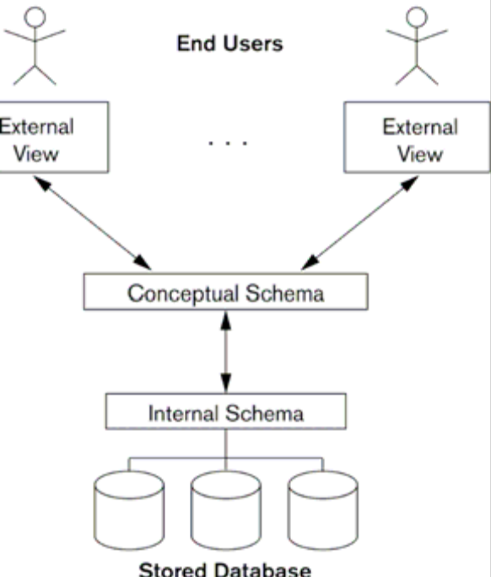

Figure 1.1 The Three Schema Architecture
The three-schema architecture is a convenient tool for the user to visualize the schema levels in a database system. Most DBMSs do not separate the three levels completely, but support the three-schema architecture to some extent. Some DBMSs may include physical-level details in the conceptual schema. In most DBMSs that support user views, external schemas are specified in the same data model that describes the conceptual-level information. Some DBMSs allow different data models to be used at the conceptual and external levels.
Notice that the three schemas are only descriptions of data; the only data that actually exists is at the physical level. In a DBMS based on the three-schema architecture, each user group refers only to its own external schema. Hence, the DBMS must transform a request specified on an external schema into a request against the conceptual schema, and then into a request on the internal schema for processing over the stored database. If the request is a database retrieval, the data extracted from the stored database must be reformatted to match the user’s external view. The processes of transforming requests and results between levels are called mappings. These mappings may be time-consuming, so some DBMSs—especially those that are meant to support small databases—do not support external views. Even in such systems, however, a certain amount of mapping is necessary to transform requests between the conceptual and internal levels.
1.12.2 Data Independence
The three-schema architecture can be used to explain the concept of data independence, which can be defined as the capacity to change the schema at one level of a database system without having to change the schema at the next higher level. We can define two types of data independence:
1. Logical data independence is the capacity to change the conceptual schema without having to change external schemas or application programs. We may change the conceptual schema to expand the database (by adding a record type or data item), or to reduce the database (by removing a record type or data item). In the latter case, external schemas that refer only to the remaining data should not be affected. Only the view definition and the mappings need be changed in a DBMS that supports logical data independence. Application programs that reference the external schema constructs must work as before, after the conceptual schema undergoes a logical reorganization. Changes to constraints can be applied also to the conceptual schema without affecting the external schemas or application programs.
2. Physical data independence is the capacity to change the internal schema without having to change the conceptual (or external) schemas. Changes to the internal schema may be needed because some physical files had to be reorganized—for example, by creating additional access structures—to improve the performance of retrieval or update. If the same data as before remains in the database, we should not have to change the conceptual schema.

Whenever we have a multiple-level DBMS, its catalogue must be expanded to include information on how to map requests and data among the various levels. The DBMS uses additional software to accomplish these mappings by referring to the mapping information in the catalogue. Data independence is accomplished because, when the schema is changed at some level, the schema at the next higher level remains unchanged; only the mapping between the two levels is changed. Hence, application programs referring to the higher-level schema need not be changed.
The three-schema architecture can make it easier to achieve true data independence, both physical and logical. However, the two levels of mappings create an overhead during compilation or execution of a query or program, leading to inefficiencies in the DBMS. Because of this, few DBMSs have implemented the full three-schema architecture.
1.13 Types of Database System
Several criteria are normally used to classify DBMSs. The first is the data model on which the DBMS is based. The main data model used in many current commercial DBMSs is the relational data model. The object data model was implemented in some commercial systems but has not had widespread use. Many legacy (older) applications still run on database systems based on the hierarchical and network data models. The relational DBMSs are evolving continuously, and, in particular, have been incorporating many of the concepts that were developed in object databases. This has led to a new class of DBMSs called object-relational DBMSs. We can hence categorize DBMSs based on the data model: relational, object, object-relational, hierarchical, network, and other. The second criterion used to classify DBMSs is the number of users supported by the system. Single-user systems support only one user at a time and are mostly used with personal computers. Multiuser systems, which include the majority of DBMSs, support multiple users concurrently. A third criterion is the number of sites over which the database is distributed. A DBMS is centralized if the data is stored at a single computer site. A centralized DBMS can support multiple users, but the DBMS and the database themselves reside totally at a single computer site. A distributed DBMS (DDBMS) can have the actual database and DBMS software distributed over many sites, connected by a computer network. Homogeneous DDBMSs use the same DBMS software at multiple sites. A recent trend is to develop software to access several autonomous preexisting databases stored under heterogeneous llBMSs. This leads to a federated DBMS (or multidatabase system), in which the participating DBMSs are loosely coupled and have a degree of local autonomy. Many DBMSs use a client-server architecture.
1.14 Summary
In this chapter we have discussed in a relatively informal manner the major components of a database system. We summarise the discussion below:
A database-management system (DBMS) is a collection of interrelated data and a set of programs to access those data. This is a collection of related data with an implicit meaning and hence is a database.
A datum – a unit of data – is a symbol or a set of symbols which is used to represent something. This relationship between symbols and what they represent is the essence of what we mean by information.
Knowledge refers to the practical use of information.
The collection of information stored in the database at a particular moment is called an instance of the database. The overall design of the database is called the database schema.
The physical schema describes the database design at the physical level, while the logical schema describes the database design at the logical level. A database may also have several schemas at the view level, sometimes called subschemas, that describe different views of the database.
Application programs are said to exhibit physical data independence if they do not depend on the physical schema, and thus need not be rewritten if the physical schema changes.
Underlying the structure of a database is the data model: a collection of conceptual tools for describing data, data relationships, data semantics, and consistency constraints.
A database system provides a data definition language to specify the database schema and a data manipulation language to express database queries and updates.
One of the main reasons for using DBMSs is to have central control of both the data and the programs that access those data. A person who has such central control over the system is called a database administrator (DBA).
1.15 Key Words
DBMS, Data Integrity, Data Persistence, Instances, Schemas, Physical Schema, Logical Schema, Data Model, DDL, DML, Data Dictionary
1.16 Self Assessment Questions
- Why would you choose a database system instead of simply storing data in operating system files? When would it make sense not to use a database system?
- What is logical data independence and why is it important?
- Explain the difference between logical and physical data independence.
- Explain the difference between external, internal, and conceptual schemas. How are these different schema layers related to the concepts of logical and physical data independence?
- What are the responsibilities of a DBA?
- Distinguish between logical and physical database design.
- Describe and define the key properties of a database system. Give an organizational example of the benefits of each property.

1.17 References/Suggested Readings
1 http://www.microsoft-accesssolutions.co.uk
2 Date, C, J, Introduction to Database Systems, 7th edition
3 Leon, Alexis and Leon, Mathews, Database Management Systems, LeonTECHWorld.

Lesson 02: Data Modelling Using Entity-Relationship Approach

Structure
2.0 Objectives
2.1 Introduction
2.2 Data Modeling In the Context of Database Design
2.3 The Entity-Relationship Model
2.4 Data Modeling As Part of Database Design
2.5 Steps In Building the Data Model
2.6 Developing the Basic Schema
2.7 Summary
2.8 Key Words
2.9 Self Assessment Questions
2.10 References/Suggested Readings

2.0 Objectives
At the end of this chapter the reader will be able to:
- Describe basic concepts of ER Model
- Describe components of a data model
- Describe basic constructs of E-R Modeling
- Describe data modeling as a part of database design process
- Describe steps in building the data model
- Describe developing the basic schema

2.1 Introduction
A data model is a conceptual representation of the data structures that are required by a database. The data structures include the data objects, the associations between data objects, and the rules which govern operations on the objects. As the name implies, the data model focuses on what data is required and how it should be organized rather than what operations will be performed on the data. To use a common analogy, the data model is equivalent to an architect's building plans.
A data model is independent of hardware or software constraints. Rather than try to represent the data as a database would see it, the data model focuses on representing the data as the user sees it in the "real world". It serves as a bridge between the concepts that make up real-world events and processes and the physical representation of those concepts in a database.
Methodology
There are two major methodologies used to create a data model: the Entity-Relationship (ER) approach and the Object Model. This document uses the Entity-Relationship approach.
2.2 Data Modelling In the Context of Database Design
Database design is defined as: "design the logical and physical structure of one or more databases to accommodate the information needs of the users in an organization for a defined set of applications". The design process roughly follows five steps:
- Planning and analysis
- Conceptual design
- Logical design
- Physical design
- Implementation
The data model is one part of the conceptual design process. The other, typically is the functional model. The data model focuses on what data should be stored in the database while the functional model deals with how the data is processed. To put this in the context of the relational database, the data model is used to design the relational tables. The functional model is used to design the queries which will access and perform operations on those tables.
Components of a Data Model
The data model gets its inputs from the planning and analysis stage. Here the modeller, along with analysts, collects information about the requirements of the database by reviewing existing documentation and interviewing end-users.
The data model has two outputs. The first is an entity-relationship diagram which represents the data structures in a pictorial form. Because the diagram is easily learned, it is valuable tool to communicate the model to the end-user. The second component is a data document. This is a document that describes in detail the data objects, relationships, and rules required by the database. The dictionary provides the detail required by the database developer to construct the physical database.
Why is Data Modelling Important?
Data modelling is probably the most labour intensive and time consuming part of the development process. Why bother especially if you are pressed for time? A common response by practitioners who write on the subject is that you should no more build a database without a model than you should build a house without blueprints.
The goal of the data model is to make sure that the all data objects required by the database are completely and accurately represented. Because the data model uses easily understood notations and natural language, it can be reviewed and verified as correct by the end-users.
The data model is also detailed enough to be used by the database developers to use as a "blueprint" for building the physical database. The information contained in the data model will be used to define the relational tables, primary and foreign keys, stored procedures, and triggers. A poorly designed database will require more time in the long-term. Without careful planning you may create a database that omits data required to create critical reports, produces results that are incorrect or inconsistent, and is unable to accommodate changes in the user's requirements.

2.3 The Entity-Relationship Model
The Entity-Relationship (ER) model was originally proposed by Peter in 1976 as a way to unify the network and relational database views. Simply stated the ER model is a conceptual data model that views the real world as entities and relationships. A basic component of the model is the Entity-Relationship diagram which is used to visually represent data objects. Since Chen wrote his paper the model has been extended and today it is commonly used for database design.
For the database designer, the utility of the ER model is:
It maps well to the relational model. The constructs used in the ER model can easily be transformed into relational tables.
It is simple and easy to understand with a minimum of training. Therefore, the model can be used by the database designer to communicate the design to the end user.
In addition, the model can be used as a design plan by the database developer to implement a data model in a specific database management software.
Basic Constructs of E-R Modelling
The ER model views the real world as a construct of entities and association between entities.
Entities
Entities are the principal data object about which information is to be collected. Entities are usually recognizable concepts, either concrete or abstract, such as person, places, things, or events which have relevance to the database. Some specific examples of entities are EMPLOYEES, PROJECTS, INVOICES. An entity is analogous to a table in the relational model.
Entities are classified as independent or dependent (in some methodologies, the terms used are strong and weak, respectively). An independent entity is one that does not rely on another for identification. A dependent entity is one that relies on another for identification.
An entity occurrence (also called an instance) is an individual occurrence of an entity. An occurrence is analogous to a row in the relational table.
Special Entity Types
Associative entities (also known as intersection entities) are entities used to associate two or more entities in order to reconcile a many-to-many relationship.
Subtypes entities are used in generalization hierarchies to represent a subset of instances of their parent entity, called the supertype, but which have attributes or relationships that apply only to the subset.
Associative entities and generalization hierarchies are discussed in more detail below.
Relationships
A Relationship represents an association between two or more entities. An example of a relationship would be:
Employees are assigned to projects
Projects have subtasks
Departments manage one or more projects
Relationships are classified in terms of degree, connectivity, cardinality, and existence. These concepts will be discussed below.
Attributes
Attributes describe the entity of which they are associated. A particular instance of an attribute is a value. For example, "Jane R. Hathaway" is one value of the attribute Name. The domain of an attribute is the collection of all possible values an attribute can have. The domain of Name is a character string.
Attributes can be classified as identifiers or descriptors. Identifiers, more commonly called keys, uniquely identify an instance of an entity. A descriptor describes a non-unique characteristic of an entity instance.
Classifying Relationships
Relationships are classified by their degree, connectivity, cardinality, direction, type, and existence. Not all modelling methodologies use all these classifications.
Degree of a Relationship
The degree of a relationship is the number of entities associated with the relationship. The n-ary relationship is the general form for degree n. Special cases are the binary, and ternary, where the degree is 2, and 3, respectively.
Binary relationships, the association between two entities are the most common type in the real world. A recursive binary relationship occurs when an entity is related to itself. An example might be "some employees are married to other employees".
A ternary relationship involves three entities and is used when a binary relationship is inadequate. Many modelling approaches recognize only binary relationships. Ternary or n-ary relationships are decomposed into two or more binary relationships.
Connectivity and Cardinality The connectivity of a relationship describes the mapping of associated entity instances in the relationship. The values of connectivity are "one" or "many". The cardinality of a relationship is the actual number of related occurrences for each of the two entities. The basic types of connectivity for relations are: one-to-one, one-to-many, and many-to-many.
A one-to-one (1:1) relationship is when at most one instance of a entity A is associated with one instance of entity B. For example, "employees in the company are each assigned their own office. For each employee there exists a unique office and for each office there exists a unique employee.
A one-to-many (1:N) relationships is when for one instance of entity A, there are zero, one, or many instances of entity B, but for one instance of entity B, there is only one instance of entity A. An example of a 1:N relationships is
A department has many employees
Each employee is assigned to one department
A many-to-many (M:N) relationship, sometimes called non-specific, is when for one instance of entity A, there are zero, one, or many instances of entity B and for one instance of entity B there are zero, one, or many instances of entity A. An example is:
employees can be assigned to no more than two projects at the same time;
projects must have assigned at least three employees
A single employee can be assigned to many projects; conversely, a single project can have assigned to it many employee. Here the cardinality for the relationship between employees and projects is two and the cardinality between project and employee is three. Many-to-many relationships cannot be directly translated to relational tables but instead must be transformed into two or more one-to-many relationships using associative entities.
Direction
The direction of a relationship indicates the originating entity of a binary relationship. The entity from which a relationship originates is the parent entity; the entity where the relationship terminates is the child entity.
The direction of a relationship is determined by its connectivity. In a one-to-one relationship the direction is from the independent entity to a dependent entity. If both entities are independent, the direction is arbitrary. With one-to-many relationships, the entity occurring once is the parent. The direction of many-to-many relationships is arbitrary.
Type
An identifying relationship is one in which one of the child entities is also a dependent entity. A non-identifying relationship is one in which both entities are independent.
Existence
Existence denotes whether the existence of an entity instance is dependent upon the existence of another, related, entity instance. The existence of an entity in a relationship is defined as either mandatory or optional. If an instance of an entity must always occur for an entity to be included in a relationship, then it is mandatory. An example of mandatory existence is the statement "every project must be managed by a single department". If the instance of the entity is not required, it is optional. An example of optional existence is the statement, "employees may be assigned to work on projects".
Generalization Hierarchies
A generalization hierarchy is a form of abstraction that specifies that two or more entities that share common attributes can be generalized into a higher level entity type called a supertype or generic entity. The lower-level of entities become the subtype, or categories, to the supertype. Subtypes are dependent entities.
Generalization occurs when two or more entities represent categories of the same real-world object. For example, Wages_Employees and Classified_Employees represent categories of the same entity, Employees. In this example, Employees would be the supertype; Wages_Employees and Classified_Employees would be the subtypes.
Subtypes can be either mutually exclusive (disjoint) or overlapping (inclusive). A mutually exclusive category is when an entity instance can be in only one category. The above example is a mutually exclusive category. An employee can either be wages or classified but not both. An overlapping category is when an entity instance may be in two or more subtypes. An example would be a person who works for a university could also be a student at that same university. The completeness constraint requires that all instances of the subtype be represented in the supertype. Generalization hierarchies can be nested. That is, a subtype of one hierarchy can be a supertype of another. The level of nesting is limited only by the constraint of simplicity. Subtype entities may be the parent entity in a relationship but not the child.
ER Notation
There is no standard for representing data objects in ER diagrams. Each modeling methodology uses its own notation. All notational styles represent entities as rectangular boxes and relationships as lines connecting boxes. Each style uses a special set of symbols to represent the cardinality of a connection. The notation used in this document is from Martin. The symbols used for the basic ER constructs are:
- Entities are represented by labeled rectangles. The label is the name of the entity. Entity names should be singular nouns.
- Relationships are represented by a solid line connecting two entities. The name of the relationship is written above the line. Relationship names should be verbs.
- Attributes, when included, are listed inside the entity rectangle. Attributes which are identifiers are underlined. Attribute names should be singular nouns.
- Cardinality of many is represented by a line ending in a crow's foot. If the crow's foot is omitted, the cardinality is one.
- Existence is represented by placing a circle or a perpendicular bar on the line. Mandatory existence is shown by the bar (looks like a 1) next to the entity for an instance is required. Optional existence is shown by placing a circle next to the entity that is optional.

Examples of these symbols are shown in Figure 2.1 below:

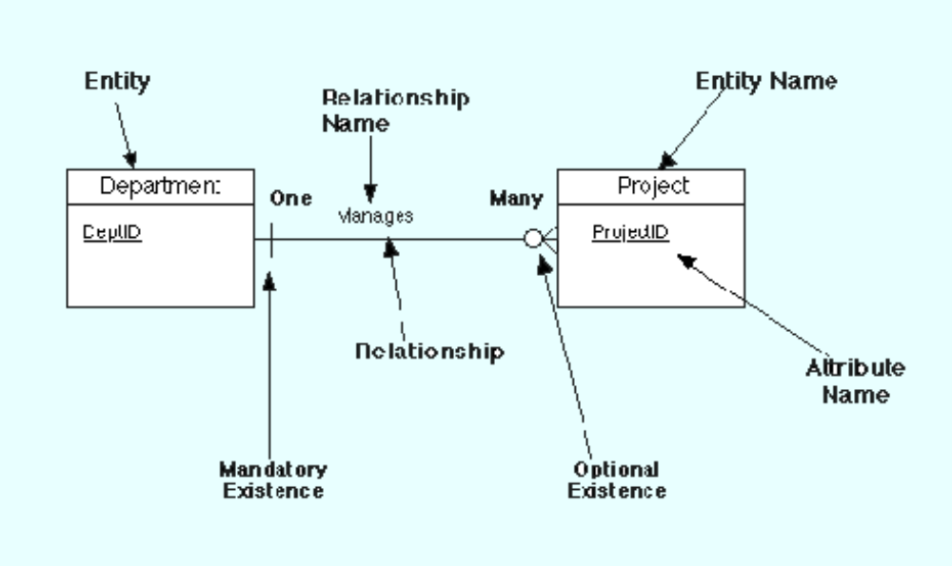
Figure 2.1 ER Notation

2.4 Data Modelling As Part of Database Design
The data model is one part of the conceptual design process. The other is the function model. The data model focuses on what data should be stored in the database while the function model deals with how the data is processed. To put this in the context of the relational database, the data model is used to design the relational tables. The functional model is used to design the queries that will access and perform operations on those tables.
Data modelling is proceeded by planning and analysis. The effort devoted to this stage is proportional to the scope of the database. The planning and analysis of a database intended to serve the needs of an enterprise will require more effort than one intended to serve a small workgroup.
The information needed to build a data model is gathered during the requirements analysis. Although not formally considered part of the data modelling stage by some methodologies, in reality the requirements analysis and the ER diagramming part of the data model are done at the same time.
Requirements Analysis
The goals of the requirements analysis are:
- To determine the data requirements of the database in terms of primitive objects
- To classify and describe the information about these objects
- To identify and classify the relationships among the objects
- To determine the types of transactions that will be executed on the database and the interactions between the data and the transactions
- To identify rules governing the integrity of the data

The modeller, or modellers, works with the end users of an organization to determine the data requirements of the database. Information needed for the requirements analysis can be gathered in several ways:
Review of existing documents - such documents include existing forms and reports, written guidelines, job descriptions, personal narratives, and memoranda. Paper documentation is a good way to become familiar with the organization or activity you need to model.
Interviews with end users - these can be a combination of individual or group meetings. Try to keep group sessions to under five or six people. If possible, try to have everyone with the same function in one meeting. Use a blackboard, flip charts, or overhead transparencies to record information gathered from the interviews.
Review of existing automated systems - if the organization already has an automated system, review the system design specifications and documentation.
The requirements analysis is usually done at the same time as the data modelling. As information is collected, data objects are identified and classified as entities, attributes, or relationship; assigned names; and, defined using terms familiar to the end-users. The objects are then modelled and analysed using an ER diagram. The diagram can be reviewed by the modeller and the end-users to determine its completeness and accuracy. If the model is not correct, it is modified, which sometimes requires additional information to be collected. The review and edit cycle continues until the model is certified as correct.
Three points to keep in mind during the requirements analysis are:
1. Talk to the end users about their data in "real-world" terms. Users do not think in terms of entities, attributes, and relationships but about the actual people, things, and activities they deal with daily.
2. Take the time to learn the basics about the organization and its activities that you want to model. Having an understanding about the processes will make it easier to build the model.
3. End-users typically think about and view data in different ways according to their function within an organization. Therefore, it is important to interview the largest number of people that time permits.

2.5 Steps in Building the Data Model
While ER model lists and defines the constructs required to build a data model, there is no standard process for doing so. Some methodologies, such as IDEFIX, specify a bottom-up development process were the model is built in stages. Typically, the entities and relationships are modelled first, followed by key attributes, and then the model is finished by adding non-key attributes. Other experts argue that in practice, using a phased approach is impractical because it requires too many meetings with the end-users.
The sequence used for this document is:
- Identification of data objects and relationships
- Drafting the initial ER diagram with entities and relationships
- Refining the ER diagram
- Add key attributes to the diagram
- Adding non-key attributes
- Diagramming Generalization Hierarchies
- Validating the model through normalization
- Adding business and integrity rules to the Model

In practice, model building is not a strict linear process. As noted above, the requirements analysis and the draft of the initial ER diagram often occur simultaneously. Refining and validating the diagram may uncover problems or missing information which require more information gathering and analysis

Identifying Data Objects and Relationships
In order to begin constructing the basic model, the modeller must analyze the information gathered during the requirements analysis for the purpose of:
- Classifying data objects as either entities or attributes
- Identifying and defining relationships between entities
- Naming and defining identified entities, attributes, and relationships
- Documenting this information in the data document

To accomplish these goals the modeller must analyze narratives from users, notes from meeting, policy and procedure documents, and, if lucky, design documents from the current information system.
Although it is easy to define the basic constructs of the ER model, it is not an easy task to distinguish their roles in building the data model. What makes an object an entity or attribute? For example, given the statement "employees work on projects". Should employees be classified as an entity or attribute? Very often, the correct answer depends upon the requirements of the database. In some cases, employee would be an entity, in some it would be an attribute.

While the definitions of the constructs in the ER Model are simple, the model does not address the fundamental issue of how to identify them. Some commonly given guidelines are:
- Entities contain descriptive information
- Attributes either identify or describe entities
- Relationships are associations between entities

These guidelines are discussed in more detail below.
- Entities
- Attributes
- Validating Attributes
- Derived Attributes and Code Values
- Relationships
- Naming Data Objects
- Object Definition
- Recording Information in Design Document

Entities
There are various definitions of an entity:
"Any distinguishable person, place, thing, event, or concept, about which information is kept"
"A thing which can be distinctly identified"
"Any distinguishable object that is to be represented in a database"
"...anything about which we store information (e.g. supplier, machine tool, employee, utility pole, airline seat, etc.). For each entity type, certain attributes are stored".
These definitions contain common themes about entities:
o An entity is a "thing", "concept" or, object". However, entities can sometimes represent the relationships between two or more objects. This type of entity is known as an associative entity.
o Entities are objects which contain descriptive information. If an data object you have identified is described by other objects, then it is an entity. If there is no descriptive information associated with the item, it is not an entity. Whether or not a data object is an entity may depend upon the organization or activity being modelled.
o An entity represents many things which share properties. They are not single things. For example, King Lear and Hamlet are both plays which share common attributes such as name, author, and cast of characters. The entity describing these things would be PLAY, with King Lear and Hamlet being instances of the entity.
o Entities which share common properties are candidates for being converted to generalization hierarchies (See below)
o Entities should not be used to distinguish between time periods. For example, the entities 1st Quarter Profits, 2nd Quarter Profits, etc. should be collapsed into a single entity called Profits. An attribute specifying the time period would be used to categorize by time
o Not everything the users want to collect information about will be an entity. A complex concept may require more than one entity to represent it. Others "things" users think important may not be entities.

Attributes
Attributes are data objects that either identify or describe entities. Attributes that identify entities are called key attributes. Attributes that describe an entity are called non-key attributes. Key attributes will be discussed in detail in a latter section.
The process for identifying attributes is similar except now you want to look for and extract those names that appear to be descriptive noun phrases.
Validating Attributes
Attribute values should be atomic, that is, present a single fact. Having disaggregated data allows simpler programming, greater reusability of data, and easier implementation of changes. Normalization also depends upon the "single fact" rule being followed. Common types of violations include:
- Simple aggregation - a common example is Person Name which concatenates first name, middle initial, and last name. Another is Address which concatenates street address, city, and zip code. When dealing with such attributes, you need to find out if there are good reasons for decomposing them. For example, do the end- users want to use the person's first name in a form letter? Do they want to sort by zip code?
- Complex codes - these are attributes whose values are codes composed of concatenated pieces of information. An example is the code attached to automobiles and trucks. The code represents over 10 different pieces of information about the vehicle. Unless part of an industry standard, these codes have no meaning to the end user. They are very difficult to process and update.
- Text blocks - these are free-form text fields. While they have a legitimate use, an over reliance on them may indicate that some data requirements are not met by the model.
- Mixed domains - this is where a value of an attribute can have different meaning under different conditions

Derived Attributes and Code Values
Two areas where data modelling experts disagree is whether derived attributes and attributes whose values are codes should be permitted in the data model.
Derived attributes are those created by a formula or by a summary operation on other attributes. Arguments against including derived data are based on the premise that derived data should not be stored in a database and therefore should not be included in the data model. The arguments in favour are:
- Derived data is often important to both managers and users and therefore should be included in the data model
- It is just as important, perhaps more so, to document derived attributes just as you would other attributes
- Including derived attributes in the data model does not imply how they will be implemented

A coded value uses one or more letters or numbers to represent a fact. For example, the value Gender might use the letters "M" and "F" as values rather than "Male" and "Female". Those who are against this practice cite that codes have no intuitive meaning to the end-users and add complexity to processing data. Those in favor argue that many organizations have a long history of using coded attributes, that codes save space, and improve flexibility in that values can be easily added or modified by means of look-up tables.
Relationships
Relationships are associations between entities. Typically, a relationship is indicated by a verb connecting two or more entities. For example:
employees are assigned to projects
As relationships are identified they should be classified in terms of cardinality, optionality, direction, and dependence. As a result of defining the relationships, some relationships may be dropped and new relationships added. Cardinality quantifies the relationships between entities by measuring how many instances of one entity are related to a single instance of another. To determine the cardinality, assume the existence of an instance of one of the entities. Then determine how many specific instances of the second entity could be related to the first. Repeat this analysis reversing the entities. For example:
Employees may be assigned to no more than three projects at a time; every project has at least two employees assigned to it.
Here the cardinality of the relationship from employees to projects is three; from projects to employees, the cardinality is two. Therefore, this relationship can be classified as a many-to-many relationship.
If a relationship can have a cardinality of zero, it is an optional relationship. If it must have a cardinality of at least one, the relationship is mandatory. Optional relationships are typically indicated by the conditional tense. For example:
An employee may be assigned to a project
Mandatory relationships, on the other hand, are indicated by words such as must have. For example:
A student must register for at least three course each semester
In the case of the specific relationship form (1:1 and 1:M), there is always a parent entity and a child entity. In one-to-many relationships, the parent is always the entity with the cardinality of one. In one-to-one relationships, the choice of the parent entity must be made in the context of the business being modeled. If a decision cannot be made, the choice is arbitrary.

Naming Data Objects
The names should have the following properties:
- Unique
- Have meaning to the end-user
- Contain the minimum number of words needed to uniquely and accurately describe the object

For entities and attributes, names are singular nouns while relationship names are typically verbs.
Some authors advise against using abbreviations or acronyms because they might lead to confusion about what they mean. Other believe using abbreviations or acronyms are acceptable provided that they are universally used and understood within the organization.
You should also take care to identify and resolve synonyms for entities and attributes. This can happen in large projects where different departments use different terms for the same thing.

Object Definition
Complete and accurate definitions are important to make sure that all parties involved in the modeling of the data know exactly what concepts the objects are representing.
Definitions should use terms familiar to the user and should precisely explain what the object represents and the role it plays in the enterprise. Some authors recommend having the end-users provide the definitions. If acronyms, or terms not universally understood are used in the definition, then these should be defined.
While defining objects, the modeller should be careful to resolve any instances where a single entity is actually representing two different concepts (homonyms) or where two different entities are actually representing the same "thing" (synonyms). This situation typically arises because individuals or organizations may think about an event or process in terms of their own function.
An example of a homonym would be a case where the Marketing Department defines the entity MARKET in terms of geographical regions while the Sales Departments thinks of this entity in terms of demographics. Unless resolved, the result would be an entity with two different meanings and properties.

Conversely, an example of a synonym would be the Service Department may have identified an entity called CUSTOMER while the Help Desk has identified the entity CONTACT. In reality, they may mean the same thing, a person who contacts or calls the organization for assistance with a problem. The resolution of synonyms is important in order to avoid redundancy and to avoid possible consistency or integrity problems.
Recording Information in Design Document
The design document records detailed information about each object used in the model. As you name, define, and describe objects, this information should be placed in this document. If you are not using an automated design tool, the document can be done on paper or with a word processor. There is no standard for the organization of this document but the document should include information about names, definitions, and, for attributes, domains.
Two documents used in the IDEF1X method of modeling are useful for keeping track of objects. These are the ENTITY-ENTITY matrix and the ENTITY-ATTRIBUTE matrix.
The ENTITY-ENTITY matrix is a two-dimensional array for indicating relationships between entities. The names of all identified entities are listed along both axes. As relationships are first identified, an "X" is placed in the intersecting points where any of the two axes meet to indicate a possible relationship between the entities involved. As the relationship is further classified, the "X" is replaced with the notation indicating cardinality.
The ENTITY-ATTRIBUTE matrix is used to indicate the assignment of attributes to entities. It is similar in form to the ENTITY-ENTITY matrix except attribute names are listed on the rows.
Figure 2.2 shows examples of an ENTITY-ENTITY matrix and an ENTITY-ATTRIBUTE matrix.

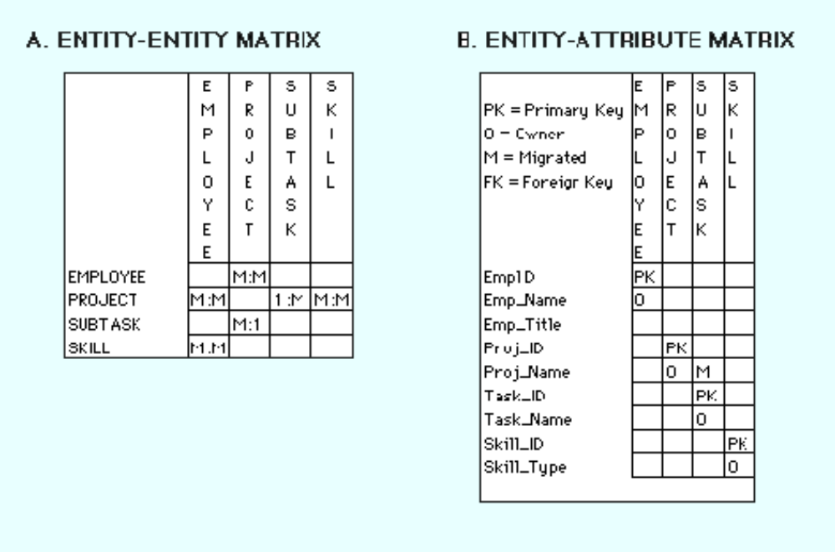
Figure 2.2
2.6 Developing the Basic Schema
Once entities and relationships have been identified and defined, the first draft of the entity relationship diagram can be created. This section introduces the ER diagram by demonstrating how to diagram binary relationships. Recursive relationships are also shown.
Binary Relationships
Figure 2.3 shows examples of how to diagram one-to-one, one-to-many, and many-to-many relationships.

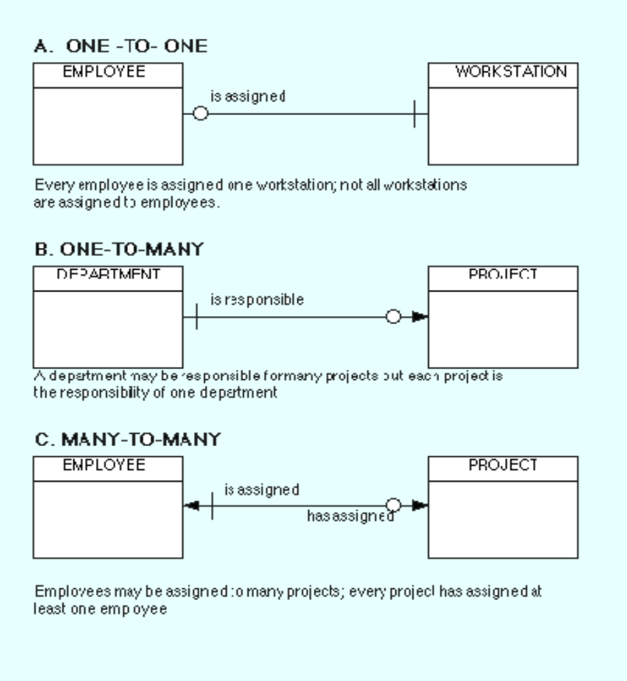
Figure 2.3 Example of Binary relationships

One-To-One
Figure 1A shows an example of a one-to-one diagram. Reading the diagram from left to right represents the relationship every employee is assigned a workstation. Because every employee must have a workstation, the symbol for mandatory existence—in this case the crossbar—is placed next to the WORKSTATION entity. Reading from right to left, the diagram shows that not all workstation are assigned to employees. This condition may reflect that some workstations are kept for spares or for loans. Therefore, we use the symbol for optional existence, the circle, next to EMPLOYEE. The cardinality and existence of a relationship must be derived from the "business rules" of the organization. For example, if all workstations owned by an organization were assigned to employees, then the circle would be replaced by a crossbar to indicate mandatory existence. One-to-one relationships are rarely seen in "real-world" data models. Some practioners advise that most one-to-one relationships should be collapsed into a single entity or converted to a generalization hierarchy.

One-To-Many
Figure 1B shows an example of a one-to-many relationship between DEPARTMENT and PROJECT. In this diagram, DEPARTMENT is considered the parent entity while PROJECT is the child. Reading from left to right, the diagram represents departments may be responsible for many projects. The optionality of the relationship reflects the "business rule" that not all departments in the organization will be responsible for managing projects. Reading from right to left, the diagram tells us that every project must be the responsibility of exactly one department.

Many-To-Many
Figure 1C shows a many-to-many relationship between EMPLOYEE and PROJECT. An employee may be assigned to many projects; each project must have many employee Note that the association between EMPLOYEE and PROJECT is optional because, at a given time, an employee may not be assigned to a project. However, the relationship between PROJECT and EMPLOYEE is mandatory because a project must have at least two employees assigned. Many-To-Many relationships can be used in the initial drafting of the model but eventually must be transformed into two one-to-many relationships. The transformation is required because many-to-many relationships cannot be represented by the relational model. The process for resolving many-to-many relationships is discussed in the next section.

Recursive relationships
A recursive relationship is an entity is associated with itself. Figure 2.4 shows an example of the recursive relationship.

An employee may manage many employees and each employee is managed by one employee.

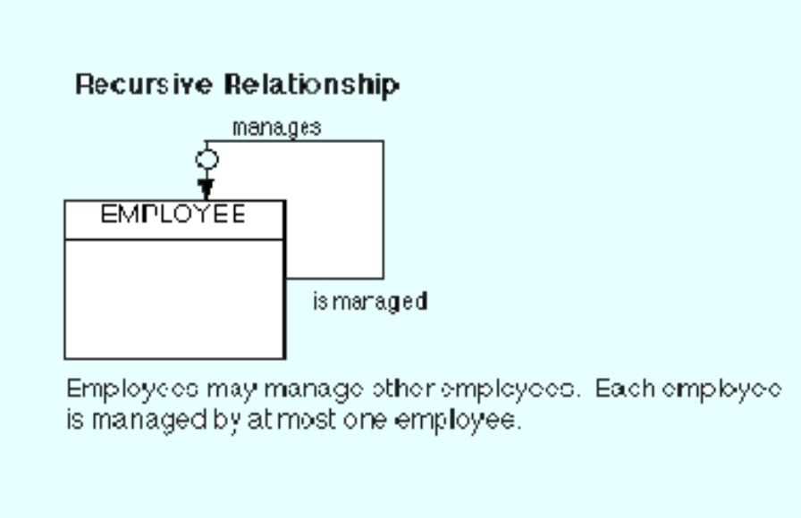
Figure 2.4 Example of Recursive relationship

2.7 Summary
- A data model is a plan for building a database. To be effective, it must be simple enough to communicate to the end user the data structure required by the database yet detailed enough for the database design to use to create the physical structure.
- The Entity-Relation Model (ER) is the most common method used to build data models for relational databases.
- The Entity-Relationship Model is a conceptual data model that views the real world as consisting of entities and relationships. The model visually represents these concepts by the Entity-Relationship diagram.
- The basic constructs of the ER model are entities, relationships, and attributes.
- Data modeling must be preceded by planning and analysis.
- Planning defines the goals of the database, explains why the goals are important, and sets out the path by which the goals will be reached.
- Analysis involves determining the requirements of the database. This is typically done by examining existing documentation and interviewing users.
- Data modeling is a bottom up process. A basic model, representing entities and relationships, is developed first. Then detail is added to the model by including information about attributes and business rules.
- The first step in creating the data model is to analyze the information gathered during the requirements analysis with the goal of identifying and classifying data objects and relationships
- The Entity-Relationship diagram provides a pictorial representation of the major data objects, the entities, and the relationships between them.

2.8 Key Words
ER Model, Database Design, Data Model, Schema, Entities, Relationship, Attributes, Cardinality
2.9 Self Assessment Questions
1. A university registrar’s office maintains data about the following entities:
• Courses, including number, title, credits, syllabus, and prerequisites;
• Course offerings, including course number, year, semester, section number, instructor(s), timings, and classroom;
• Students, including student-id, name, and program;
• Instructors, including identification number, name, department, and title.

Further, the enrollment of students in courses and grades awarded to students in each course they are enrolled for must be appropriately modeled.Construct a E-R diagram for registrar’s office. Document all assumptions that you make about the mapping constraints
2. Design an E-R diagram for keeping track of the exploits of your favorite sports team. You should store the matches played, the scores in each match, the players in each match, and individual player statistics for each match. Summary statistics should be modeled as derived attributes.
3. Explain the significance of ER Model for Database design?
4. Enumerate the basic constructs of ER Model

2.10 References/Suggested Readings
1. Date, C.J., Introduction to Database Systems (7th Edition) Addison Wesley, 2000
2. Leon, Alexis and Leon, Mathews, Database Management Systems, LeonTECHWorld
3. Elamasri R . and Navathe, S., Fundamentals of Database Systems (3rd Edition), Pearsson Education, 2000.

Lesson 03: Relational Model

Structure
3.0 Objectives
3.1 Introduction
3.2 Relational Model Concepts
3.3 Relational Model Constraints
3.4 Relational Languages
3.5 Relational Algebra
3.6 A Relational Database Management Systems-ORACLE
3.7 Summary
3.8 Key Words
3.9 Self Assessment Questions
3.10 References/Suggested Readings
3.0 Objectives
At the end of this chapter the reader will be able to:
- Describe Relational Model Concepts
- Describe properties of a relation and relational keys
- Describe relational model/integrity constraints
- Describe The Relational Algebra
- Introduce Oracle- A relational database management system
3.1 Introduction
The principles of the relational model were first outlined by Dr. E. F. Codd in a June 1970 paper called "A Relational Model of Data for Large Shared Data Banks:' In this paper. Dr. Codd proposed the relational model for database systems. The more popular models used at that time were hierarchical and network, or even simple flat file data structures. Relational database management systems (RDBMS) soon became very popular, especially for their ease of use and flexibility in structure. In addition, a number of innovative vendors, such as Oracle, supplemented the RDBMS \with a suite of powerful application development and user products, providing a total solution.
Earlier we saw how to convert an unorganized text description of information requirements into a conceptual design, by the use of ER diagrams. The advantage of ER diagrams is that they force you to identify data requirements that are implicitly known, but not explicitly written down in the original description. Here we will see how to convert this ER into a logical design (this will be defined below) of a relational database. The logical model is also called a Relational Model.
3.2 Relational Model Concepts
We shall represent a relation as a table with columns and rows. Each column of the table has a name, or attribute. Each row is called a tuple.
• Domain: a set of atomic values that an attribute can take
• Attribute: name of a column in a particular table (all data is stored in tables). Each attribute Ai must have a domain, dom(A_{i}).
• Relational Schema: The design of one table, containing the name of the table (i.e. the name of the relation), and the names of all the columns, or attributes.

Example: STUDENT( Name, SID, Age, GPA)
• Degree of a Relation: the number of attributes in the relation's schema.
• Tuple, t, of R( A1, A2, A3, …, An): an ORDERED set of values, < v1, v2, v3, …, vn>, where each v_{i} is a value from dom( A_{i}).
• Relation Instance, r( R): a set of tuples; thus, r( R) = { t1, t2, t3, …, tm}
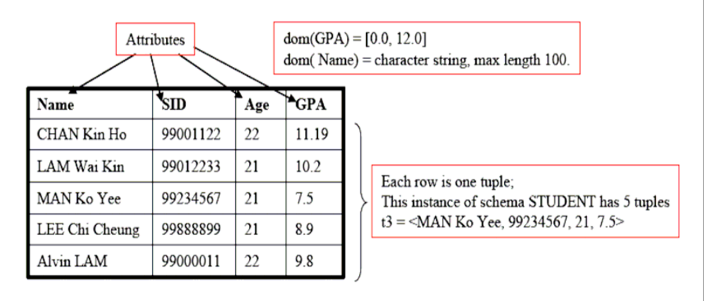

NOTES:
1. The tuples in an instance of a relation are not considered to be ordered __ putting the rows in a different sequence does not change the table.
2. Once the schema, R( A1, A2, A3, …, An) is defined, the values, vi, in each tuple, t, must be ordered as t = <v1, v2, v3, …, vn>

3.2.1 Properties of relations
Properties of database relations are:
- relation name is distinct from all other relations
- each cell of relation contains exactly one atomic (single) value
- each attribute has a distinct name
- values of an attribute are all from the same domain
- order of attributes has no significance
- each tuple is distinct; there are no duplicate tuples
- order of tuples has no significance, theoretically.

3.2.2 Relational keys
There are two kinds of keys in relations. The first are identifying keys: the primary key is the main concept, while two other keys – super key and candidate key – are related concepts. The second kind is the foreign key.

Identity Keys
Super Keys
A super key is a set of attributes whose values can be used to uniquely identify a tuple within a relation. A relation may have more than one super key, but it always has at least one: the set of all attributes that make up the relation.
Candidate Keys
A candidate key is a super key that is minimal; that is, there is no proper subset that is itself a superkey. A relation may have more than one candidate key, and the different candidate keys may have a different number of attributes. In other words, you should not interpret 'minimal' to mean the super key with the fewest attributes.
A candidate key has two properties:
(i) in each tuple of R, the values of K uniquely identify that tuple (uniqueness)
(ii) no proper subset of K has the uniqueness property (irreducibility).
Primary Key
The primary key of a relation is a candidate key especially selected to be the key for the relation. In other words, it is a choice, and there can be only one candidate key designated to be the primary key.
Relationship between identity keys
The relationship between keys:
Superkey ⊇ Candidate Key ⊇ Primary Key
Foreign keys
The attribute(s) within one relation that matches a candidate key of another relation. A relation may have several foreign keys, associated with different target relations.
Foreign keys allow users to link information in one relation to information in another relation. Without FKs, a database would be a collection of unrelated tables.
3.3 Relational Model Constraints
Integrity Constraints
Each relational schema must satisfy the following four types of constraints.
A. Domain constraints
Each attribute Ai must be an atomic value from dom( Ai) for that attribute.
The attribute, Name in the example is a BAD DESIGN (because sometimes we may want to search a person by only using their last name.
B. Key Constraints
Superkey of R: A set of attributes, SK, of R such that no two tuples in any valid relational instance, r( R), will have the same value for SK. Therefore, for any two distinct tuples, t1 and t2 in r( R),
t1[ SK] != t2[SK].
Key of R: A minimal superkey. That is, a superkey, K, of R such that the removal of ANY attribute from K will result in a set of attributes that are not a superkey.
Example CAR( State, LicensePlateNo, VehicleID, Model, Year, Manufacturer)
This schema has two keys:
K1 = { State, LicensePlateNo}
K2 = { VehicleID }
Both K1 and K2 are superkeys.
K3 = { VehicleID, Manufacturer} is a superkey, but not a key (Why?).
If a relation has more than one keys, we can select any one (arbitrarily) to be the primary key. Primary Key attributes are underlined in the schema:
CAR(State, LicensePlateNo, VehicleID, Model, Year, Manufacturer)
C. Entity Integrity Constraints
The primary key attribute, PK, of any relational schema R in a database cannot have null values in any tuple. In other words, for each table in a DB, there must be a key; for each key, every row in the table must have non-null values. This is because PK is used to identify the individual tuples.
Mathematically, t[PK] != NULL for any tuple t € r( R).
D. Referential Integrity Constraints
Referential integrity constraints are used to specify the relationships between two relations in a database.
Consider a referencing relation, R1, and a referenced relation, R2. Tuples in the referencing relation, R1, have attributed FK (called foreign key attributes) that reference the primary key attributes of the referenced relation, R2. A tuple, t1, in R1 is said to reference a tuple, t2, in R2 if t1[FK] = t2[PK].
A referential integrity constraint can be displayed in a relational database schema as a directed arc from the referencing (foreign) key to the referenced (primary) key. Examples are shown in the figure below:
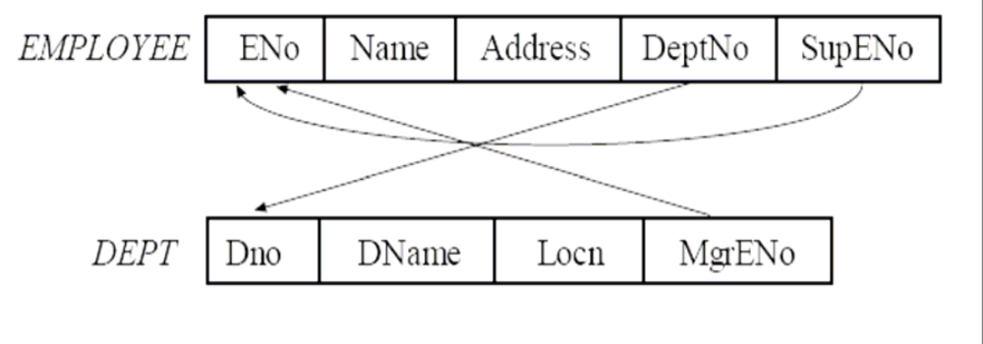
ER-to-Relational Mapping
Now we are ready to lay down some informal methods to help us create the Relational schemas from our ER models. These will be described in the following steps:
- For each regular entity, E, in the ER model, create a relation R that includes all the simple attributes of E. Select the primary key for E, and mark it.
- For each weak entity type, W, in the ER model, with the Owner entity type, E, create a relation R with all attributes of W as attributes of W, plus the primary key of E. [Note: if there are identical tuples in W which share the same owner tuple, then we need to create an additional index attribute in W.]
- For each binary relation type, R, in the ER model, identify the participating entity types, S and T.
- For 1:1 relationship between S and T
Choose one relation, say S. Include the primary key of T as a foreign key of S.
- For 1:N relationship between S and T
Let S be the entity on the N side of the relationship. Include the primary key of T as a foreign key in S.
- For M: N relation between S and T
Create a new relation, P, to represent R. Include the primary keys of both, S and T as foreign keys of P.
4. For each multi-valued attribute A, create a new relation, R, that includes all attributes corresponding to A, plus the primary key attribute, K, of the relation that represents the entity type/relationship type that has A as an attribute.
5. For each n-ary relationship type, n > 2, create a new relation S. Include as foreign key attributes in S the primary keys of the relations representing each of the participating entity types. Also include any simple attributes of the n-ary relationship type as attributes of S.

3.4 Relational Languages
We have so far considered the structure of a database; the relations and the associations between relations. In this section we consider how useful data may be extracted and filtered from database tables. A relational language is needed to express these queries in a well defined way. A relational language is an abstract language which provides the database user with an interface through which they can specify data to be retrieved according to certain selection criteria. The two main relational languages are relational algebra and relational calculus. Relational algebra, which we focus on here, provides the user with a set of operators which may be used to create new (temporary) relations based on information contained in existing relations. Relational calculus, on the other hand, provides a set of key words to allow the user to make ad hoc inquiries.
3.5 Relational Algebra
Relational algebra is a procedural language consisting of a set of operators. Each operator takes one or more relations as its input and produces one relation as its output. The seven basic relational algebra operations are Selection, Projection, Joining, Union, Intersection, Difference and Division. It is important to note that these operations do not alter the database. The relation produced by an operation is available to the user but it is not stored in the database by the operation.
Selection (also called Restriction)
The SELECT operator selects all tuples from some relation, so that some attributes in each tuple satisfy some condition. A new relation containing the selected tuples is then created as output. Suppose we have the relation STORES:
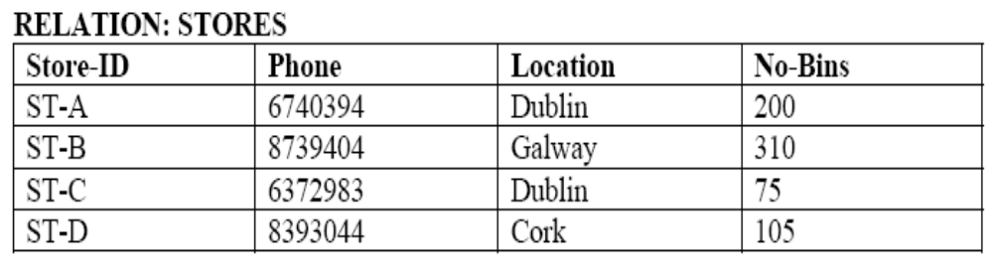
The relational operation:
R l = SELECT STORES WHERE Location = 'Dublin'
selects all tuples for stores that are located in Dublin and creates the new relation R1 which appears as follows:
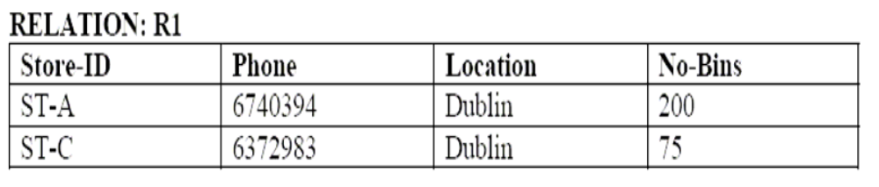
We can also impose conditions on more than one attribute. For example,
R2 = SELECT STORES WHERE Location = 'Dublin' AND No-Bins > 100

This operation selects only one tuple from the relation:
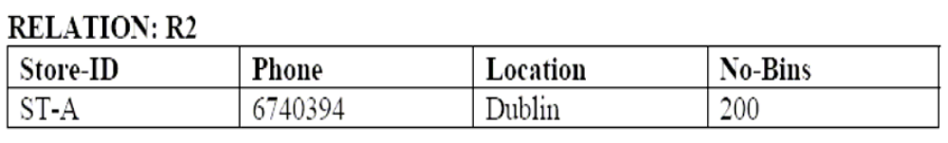

Projection
The projection operator constructs a new relation from some existing relation by selecting only specified attributes of the existing relation and eliminating duplicate tuples in the newly formed relation. For example,
R3 = PROJECT STORES OVER Store-ID, Location
results in:
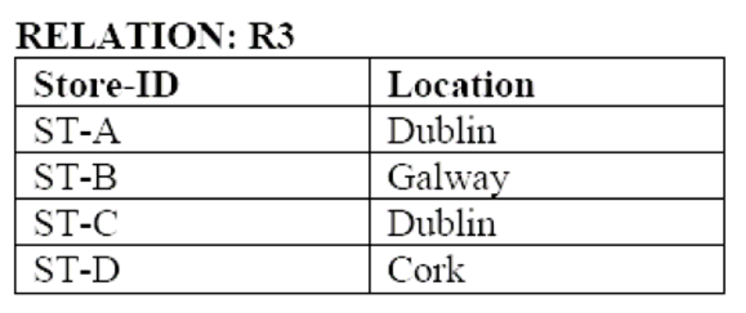
Given the following operation,
R4 = PROJECT STORES OVER Location
What would the relation R4 look like?
Joining
Joining is a operation for combining two relations into a single relation. At the outset, it requires choosing the attributes to match the tuples in each relation. Tuples in different relations but with the same value of matching attributes are combined into a single tuple in the output relation.
For example, with a new relation ITEMS:
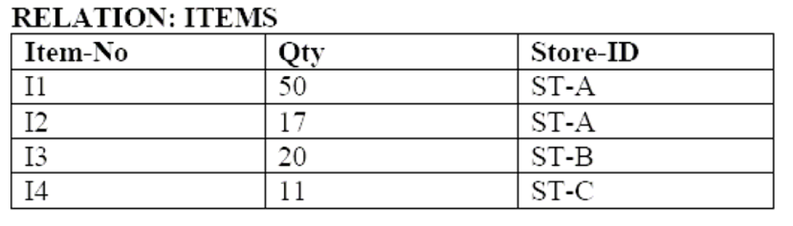
… and our previous STORES relation:

if we joined ITEMS to STORES using the operator:
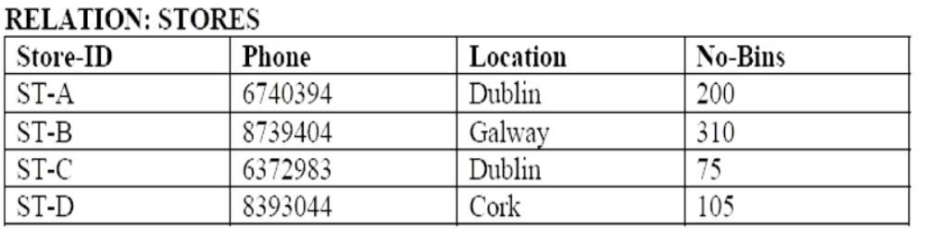
R5 = JOIN STORES, ITEMS OVER Store-ID
the resulting relation R5 would appear as follows:
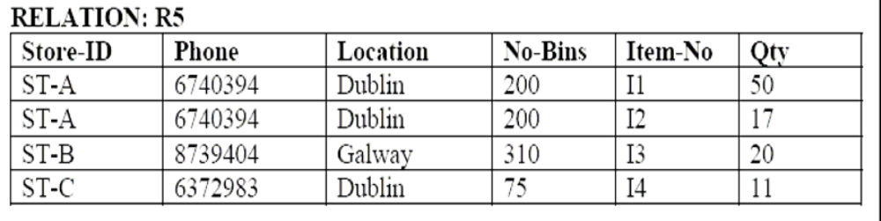

This relation resulted from a joining of ITEMS and STORES over the common attribute Store-ID, i.e. any tuples of each relation which contained the same value of Store-ID were joined together to form a single tuple.
Joining relations together based on equality of values of common attributes is called an equijoin. Conditions of join may be other than equality - we may also have a ‘greater-than’ or ‘less-than’ join.
When duplicate attributes are removed from the result of an equijoin this is called an natural join. The example above is such a natural join - as Store-ID appears only once in the result.
Note that there is often a connection between keys (primary and foreign) and the attributes over which a join is performed in order to amalgamate information from multiple related tables in a database. In the above example, ITEMS.Store_ID is a foreign key reflecting the primary key STORE.Store_ID. When we join on Store_ID the relationship between the tables is expressed explicitly in the resulting output table. To illustrate, the relationship between these relations can be expressed as an E-R diagram, shown below.
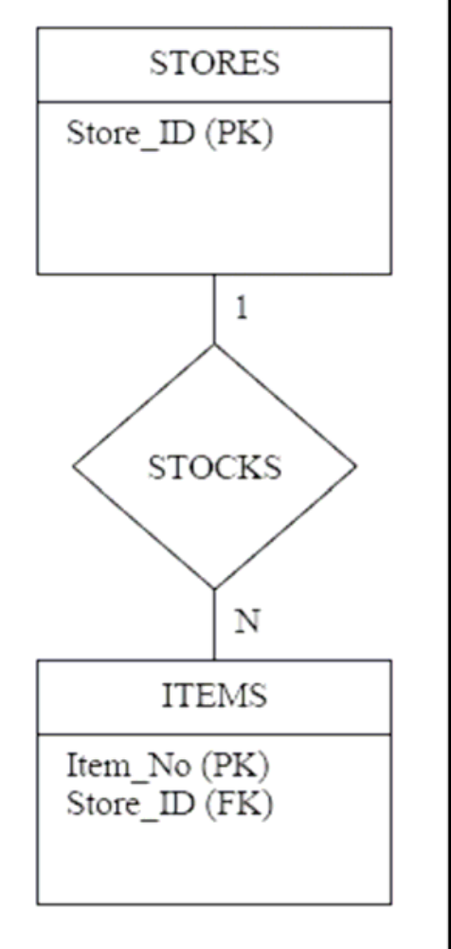

Union, Intersection and Difference
These are the standard set operators. The requirement for carrying out any of these operations is that the two operand relations are union-compatible - i.e. they have the same number of attributes (say n) and the i^{th} attribute of each relation (i = l,…,n) must be from the same domain (they do not have to have the same attribute names).
The UNION operator builds a relation consisting of all tuples appearing in either or both of two specified relations.
The INTERSECT operator builds a relation consisting of all tuples appearing strictly in both specified relations.
The DIFFERENCE operator builds a relation consisting of all tuples appearing in the first, but not the second of two specified relations.
This may be represented diagrammatically as shown below.
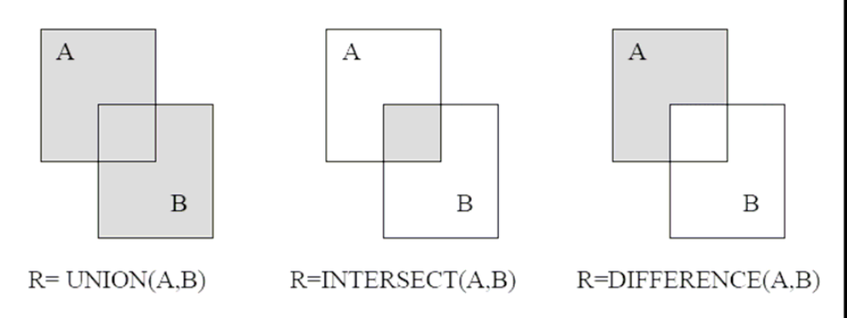

As an exercise, find:
C = UNION(A,B), C = INTERSTION(A,B) and C= DIFFERENCE(A,B).
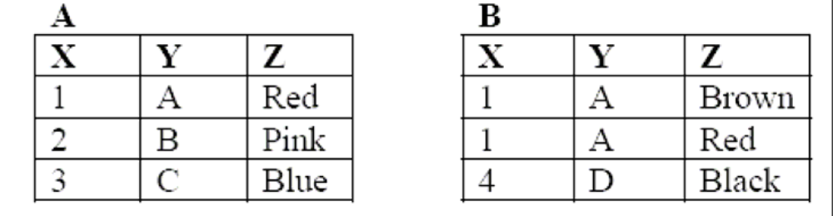

Division
In its simplest form, this operation has a binary relation R(X,Y) as the dividend and a divisor that includes Y. The output is a set, S, , of values of X such that x € S if there is a row (x,y) in R for each y value in the divisor.
As an example, suppose we have two relations R6 and R7:
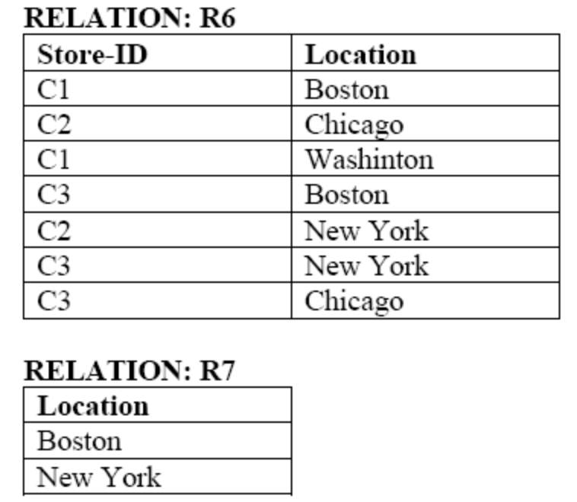
The operation:
R8 = R6 / R7
will give the result:
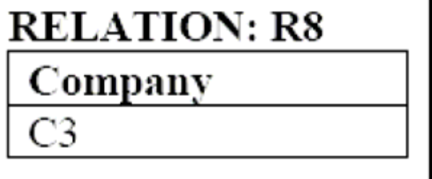
This is because C3 is the only company for which there is a row with Boston and New York. The other companies, C1 and C2, do not satisfy this condition.
3.7 Summary
- To convert this ER into a logical design of a relational database. The logical model is also called a Relational Model.
- Domain: a set of atomic values that an attribute can take
- Attribute: name of a column in a particular table (all data is stored in tables).
- The design of one table, containing the name of the table (i.e. the name of the relation), and the names of all the columns, or attributes is called relational schema.
- The number of attributes in the relation's schema is called the degree of a relation.
- A super key is a set of attributes whose values can be used to uniquely identify a tuple within a relation.
- A candidate key is a super key that is minimal; that is, there is no proper subset that is itself a superkey.
- The primary key of a relation is a candidate key especially selected to be the key for the relation.
- The attribute(s) within one relation that matches a candidate key of another relation is called foreign key(s).
10. Each relational schema must satisfy the following four types of constraints viz. domain constraints, key constraints, entity integrity and referential integrity constraints.
11. Relational algebra is a procedural language consisting of a set of operators. Each operator takes one or more relations as its input and produces one relation as its output.
12. The seven basic relational algebra operations are Selection, Projection, Joining, Union, Intersection, Difference and Division.

3.8 Key Words
Relation, Integrity Constraints, Relational Algebra, Primary Key, Foreign Key, Super Key, Candidate Key, Degree of a Relation, Projection, Join
3.9 Self assessment Questions
- Explain in brief the relational approach to data base structures.
- What is a relation? What are its characteristics?
- Explain any three relational operators with example.
- Explain various relational constraints with example.
- Explain Relational Algebra. What are the relational algebra operations that can be performed?
- What are the advantages of Relational Model?

3.10 References/Suggested Readings
- Date, C.J., Introduction to Database Systems (7th Edition) Addison Wesley, 2000
- Leon, Alexis and Leon, Mathews, Database Management Systems, LeonTECHWorld
- Elamasri R . and Navathe, S., Fundamentals of Database Systems (3rd Edition), Pearsson Education, 2000.

Lesson 4: SQL
Structure
4.0 Objectives
4.1 Introduction and History
4.2 What is SQL?
4.3 SQL Commands
4.4 Data Definition Language (DDL) in SQL
4.5 Data Manipulation Language in SQL (DML)
4.6 Transaction Control Language in SQL(TCL)
4.7 Constraints in SQL
4.8 Indexes in SQL
4.9 Summary
4.10 Key Words
4.11 Self Assessment Questions
4.12 References/Suggested Readings
4.0 Objectives
At the end of this chapter the reader will be able to:
- Describe history of SQL
- Describe various SQL commands
- Define characteristics of SQL commands
- Describe DDL,DML and DCL commands
- Describe constraints and indexes in SQL
4.1 Introduction and History
In this chapter we want to emphasize that SQL is both deep and wide. Deep in the sense that it is implemented at many levels of database communication, from a simple Access form list box right up to high-volume communications between mainframes. SQL is widely implemented in that almost every DBMS supports SQL statements for communication. The reason for this level of acceptance is partially explained by the amount of effort that went into the theory and development of the standards.
Current State
So the ANSI-SQL group has published three standards over the years:
• SQL89 (SQL1)
• SQL92 (SQL2)
• SQL99 (SQL3)

The vast majority of the language has not changed through these updates. We can all profit from the fact that almost all of the code we wrote to SQL standards of 1989 is still perfectly usable. Or in other words, as a new student of SQL there is over ten years of SQL code out there that needs your expertise to maintain and expand.
Most DBMS are designed to meet the SQL92 standard. Virtually all of the material in this book was available in the earlier standards as well. Since many of the advanced features of SQL92 have yet to be implemented by DBMS vendors, there has been little pressure for a new version of the standard. Nevertheless a SQL99 standard was developed to address advanced issues in SQL. All of the core functions of SQL, such as adding, reading and modifying data, are the same. Therefore, the topics in this book are not affected by the new standard. As of early 2001, no vendor has implemented the SQL99 standard.
There are three areas where there is current development in SQL standards. First entails improving Internet access to data, particularly to meet the needs of the emerging XML standards. Second is integration with Java, either through Sun's Java Database Connectivity (JDBC) or through internal implementations. Last, the groups that establish SQL standards are considering how to integrate object- based programming models.
4.2 What is SQL?
Structured Query Language, commonly abbreviated to SQL and pronounced as “sequel”, is not a conventional computer programming language in the normal sense of the phrase. It allows users to access data in relational database management systems. SQL is about data and results; each SQL statement returns a result, whether that result is a query, an update to a record or the creation of a database table. SQL is most often used to address a relational database, which is what some people refer to as a SQL database. So in brief we can describe SQL as follows:
- SQL stands for Structured Query Language
- SQL allows you to access a database
- SQL can execute queries against a database
- SQL can retrieve data from a database
- SQL can insert new records in a database
- SQL can delete records from a database
- SQL can update records in a database
- SQL is easy to learn
Creating a Database
Many database systems have graphical interfaces which allow developers (and users) to create, modify and otherwise interact with the underlying database management system (DBMS). However, for the purposes of this chapter all interactions with the DBMS will be via SQL commands rather than via menus.

4.3 SQL Commands
There are three groups of commands in SQL:
1. Data Definition
2. Data Manipulation and
3. Transaction Control
4.3.1 Characteristics of SQL Commands
Here you can see that SQL commands follow a number of basic rules:
• SQL keywords are not normally case sensitive, though this in this tutorial all commands (SELECT, UPDATE etc) are upper-cased.
• Variable and parameter names are displayed here as lower-case.
• New-line characters are ignored in SQL, so a command may be all on one line or broken up across a number of lines for the sake of clarity.
• Many DBMS systems expect to have SQL commands terminated with a semi-colon character.
4.4 Data Definition Language (DDL) in SQL
The Data Definition Language (DDL) part of SQL permits database tables to be created or deleted. We can also define indexes (keys), specify links between tables, and impose constraints between database tables.
The most important DDL statements in SQL are:
- CREATE TABLE - creates a new database table
- ALTER TABLE - alters (changes) a database table
- DROP TABLE - deletes a database table

How to create table
Creating a database is remarkably straightforward. The SQL command which you have to give is just:
CREATE DATABASE dbname;
In this example you will call the database GJUniv, so the command which you have to give is:
CREATE DATABASE GJUniv;
Once the database is created it, is possible to start implementing the design sketched out previously.
So you have created the database and now it's time to use some SQL to create the tables required by the design. Note that all SQL keywords are shown in upper case, variable names in a mixture of upper and lower case.
The SQL statement to create a table has the basic form:
CREATE TABLE name( col1 datatype, col2 datatype, …);
So, to create our User table we enter the following command:
CREATE TABLE User (FirstName TEXT, LastName TEXT, UserID TEXT, Dept TEXT, EmpNo INTEGER, PCType TEXT);
The TEXT datatype, supported by many of the most common DBMS, specifies a string of characters of any length. In practice there is often a default string length which varies by product. In some DBMS TEXT is not supported, and instead a specific string length has to be declared. Fixed length strings are often called CHAR(x), VCHAR(x) or VARCHAR(x), where x is the string length. In the case of INTEGER there are often multiple flavors of integer available. Remembering that larger integers require more bytes for data storage, the choice of int size is usually a design decision that ought to be made up front.
How to Modify table
Once a table is created its structure is not necessarily fixed in stone. In time requirements change and the structure of the database is likely to evolve to match your wishes. SQL can be used to change the structure of a table, so, for example, if we need to add a new field to our User table to tell us if the user has Internet access, then we can execute an SQL ALTER TABLE command as shown below:
ALTER TABLE User ADD COLUMN Internet BOOLEAN;
To delete a column the ADD keyword is replaced with DROP, so to delete the field we have just added the SQL is:
ALTER TABLE User DROP COLUMN Internet;
How to delete table
If you have already executed the original CREATE TABLE command your database will already contain a table called User, so let's get rid of that using the DROP command:
DROP TABLE User;
And now we'll recreate the User table we'll use throughout the rest of this tutorial:
CREATE TABLE User (FirstName VARCHAR (20), LastName VARCHAR (20),
UserID VARCHAR(12) UNIQUE, Dept VARCHAR(20), EmpNo INTEGER UNIQUE, PCType VARCHAR(20);
4.5 Data Manipulation Language in SQL (DML)
SQL language also includes syntax to update, insert, and delete records. These query and update commands together form the Data Manipulation Language (DML) part of SQL:
- INSERT INTO - inserts new data into a database table
- UPDATE - updates data in a database table
- DELETE - deletes data from a database table
- SELECT - extracts data from a database table

How to Insert Data
Having now built the structure of the database it is time to populate the tables with some data. In the vast majority of desktop database applications data entry is performed via a user interface built around some kind of GUI form. The form gives a representation of the information required for the application, rather than providing a simple mapping onto the tables. So, in this sample application you would imagine a form with text boxes for the user details, drop-down lists to select from the PC table, drop-down selection of the software packages etc. In such a situation the database user is shielded both from the underlying structure of the database and from the SQL which may be used to enter data into it. However we are going to use the SQL directly to populate the tables so that we can move on to the next stage of learning SQL.
The command to add new records to a table (usually referred to as an append query), is:
INSERT INTO target [(field1[, field2[, ...]])]
VALUES (value1[, value2[, ...]);
So, to add a User record for user Jim Jones, we would issue the following INSERT query:
INSERT INTO User (FirstName, LastName, UserID, Dept, EmpNo, PCType) 6
VALUES ("Jim", "Jones", "Jjones","Finance", 9, "DellDimR450");
Obviously populating a database by issuing such a series of SQL commands is both tedious and prone to error, which is another reason why database applications have front-ends. Even without a specifically designed front-end, many database systems - including MS Access - allow data entry direct into tables via a spreadsheet-like interface.
The INSERT command can also be used to copy data from one table into another. For example, The SQL query to perform this is:
INSERT INTO User ( FirstName, LastName, UserID, Dept, EmpNo, PCType, Internet )
SELECT FirstName, LastName, UserID, Dept, EmpNo, PCType, Internet
FROM NewUsers;

How to Update Data
The INSERT command is used to add records to a table, but what if you need to make an amendment to a particular record? In this case the SQL command to perform updates is the UPDATE command, with syntax:
UPDATE table
SET newvalue
WHERE criteria;
For example, let's assume that we want to move user Jim Jones from the Finance department to Marketing. Our SQL statement would then be:
UPDATE User
SET Dept="Marketing"
WHERE EmpNo=9;

Notice that we used the EmpNo field to set the criteria because we know it is unique. If we'd used another field, for example LastName, we might have accidentally updated the records for any other user with the same surname.
The UPDATE command can be used for more than just changing a single field or record at a time. The SET keyword can be used to set new values for a number of different fields, so we could have moved Jim Jones from Finance to marketing and changed the PCType as well in the same statement (SET Dept="Marketing", PCType="PrettyPC"). Or if all of the Finance department were suddenly granted Internet access then we could have issued the following SQL query:
UPDATE User
SET Internet=TRUE
WHERE Dept="Finance";
You can also use the SET keyword to perform arithmetical or logical operations on the values. For example if you have a table of salaries and you want to give everybody a 10% increase you can issue the following command:
UPDATE PayRoll
SET Salary=Salary * 1.1;
How to Delete Data
Now that we know how to add new records and to update existing records it only remains to learn how to delete records before we move on to look at how we search through and collate data. As you would expect SQL provides a simple command to delete complete records. The syntax of the command is:
DELETE [table.*]
FROM table
WHERE criteria;
Let's assume we have a user record for John Doe, (with an employee number of 99), which we want to remove from our User we could issue the following query:
DELETE *
FROM User
WHERE EmpNo=99;
In practice delete operations are not handled by manually keying in SQL queries, but are likely to be generated from a front end system which will handle warnings and add safe-guards against accidental deletion of records.
Note that the DELETE query will delete an entire record or group of records. If you want to delete a single field or group of fields without destroying that record then use an UPDATE query and set the fields to Null to over-write the data that needs deleting. It is also worth noting that the DELETE query does not do anything to the structure of the table itself, it deletes data only. To delete a table, or part of a table, then you have to use the DROP clause of an ALTER TABLE query.

4.6 Transaction Control Language in SQL(TCL)
The SQL Data Control Language (DCL) provides security for your database. The DCL consists of the GRANT, REVOKE, COMMIT, and ROLLBACK statements. GRANT and REVOKE statements enable you to determine whether a user can view, modify, add, or delete database information.
Working with transaction control
Applications execute a SQL statement or group of logically related SQL statements to perform a database transaction. The SQL statement or statements add, delete, or modify data in the database.
Transactions are atomic and durable. To be considered atomic, a transaction must successfully complete all of its statements; otherwise none of the statements execute. To be considered durable, a transaction's changes to a database must be permanent.
Complete a transaction by using either the COMMIT or ROLLBACK statements. COMMIT statements make permanent the changes to the database created by a transaction. ROLLBACK restores the database to the state it was in before the transaction was performed.
SQL Transaction Control Language Commands (TCL.)
This page contains some SQL TCL commands that I think it might be useful. Each command's description is taken and modified from the SQLPlus help. They are provided as is and most likely are partially described. So, if you want more detail or other commands, please use HELP in the SQLPlus directly.
COMMIT
PURPOSE:
To end your current transaction and make permanent all changes performed in the transaction. This command also erases all savepoints in the transaction and releases the transaction's locks. You can also use this command to manually commit an in-doubt distributed transaction.
SYNTAX:
COMMIT [WORK]
[ COMMENT 'text'
| FORCE 'text' [, integer] ]
Where:
- WORK: is supported only for compliance with standard SQL. The statements COMMIT and COMMIT WORK are equivalent.
- COMMENT: specifies a comment to be associated with the current transaction. The 'text' is a quoted literal of up to 50 characters that Oracle stores in the data dictionary view DBA_2PC_PENDING along with the transaction ID if the transaction becomes in-doubt.
- FORCE: manually commits an in-doubt distributed transaction. The transaction is identified by the 'text' containing its local or global transaction ID. To find the IDs of such transactions, query the data dictionary view DBA_2PC_PENDING. You can also use the integer to specifically assign the transaction a system change number (SCN). If you omit the integer, the transaction is committed using the current SCN.

COMMIT statements using the FORCE clause are not supported in PL/SQL.

PREREQUISITES:
You need no privileges to commit your current transaction. To manually commit a distributed in-doubt transaction that you originally committed, you must have FORCE TRANSACTION system privilege. To manually commit a distributed in-doubt transaction that was originally committed by another user, you must have FORCE ANY TRANSACTION system privilege.
Example:
To commit your current transaction, enter
SQL> COMMIT WORK;
Commit complete.
ROLLBACK
PURPOSE:
To undo work done in the current transaction, you can also use this command to manually undo the work done by an in-doubt distributed transaction.
SYNTAX:
ROLLBACK [WORK]
[ TO [SAVEPOINT] savepoint
| FORCE 'text' ]
Where:
- WORK: is optional and is provided for ANSI compatibility.
- TO: rolls back the current transaction to the specified savepoint. If you omit this clause, the ROLLBACK statement rolls back the entire transaction.
- FORCE: manually rolls back an in-doubt distributed transaction. The transaction is identified by the 'text' containing its local or global transaction ID. To find the IDs of such transactions, query the data dictionary view DBA_2PC_PENDING. ROLLBACK statements with the FORCE clause are not supported in PL/SQL.
PREREQUISITES: To roll back your current transaction, no privileges are necessary. To manually roll back an in-doubt distributed transaction that you originally committed, you must have FORCE TRANSACTION system privilege. To manually roll back an in-doubt distributed transaction originally committed by another user, you must have FORCE ANY TRANSACTION system privilege.
Example:
To rollback your current transaction, enter
SQL> ROLLBACK;
Rollback complete.
Creating users
This section covers the following information:
- Creating database administrators
- Creating users

The CREATE statement is not a part of the Data Control Language, but rather the Data Definition Language. This chapter addresses the CREATE statement as it relates to the creation of database administrators and users.
Creating database administrators
Database security is defined and controlled by database administrators (DBAs). Within the scope of database security, DBAs are responsible for:
- Adding users.
- Deleting users.
- Permitting access to specific database objects.
- Limiting or prohibiting access to database objects.
- Granting users privileges to view or modify database objects.
- Modifying or revoking privileges that have been granted to the users.

A user who initially creates a database becomes its default administrator. Therefore, this initial user has the authority to create other administrator accounts for that particular database. OpenEdge Studio offers two methods for creating DBAs:
- In SQL, the DBA uses the CREATE statement to create a user and then uses the GRANT statement to provide the user with administrative privileges.
- In Progress 4GL, a DBA uses the Data Administration Tool to create other administrators.

Creating users
Use the following syntax to employ the CREATE USER statement:
Syntax
CREATE USER 'username', 'password';
Creating users
Use the following syntax to employ the CREATE USER statement:
Syntax
CREATE USER 'username', 'password';
In Example 4-1, an account with DBA privileges creates the 'username' 'GPS' with 'password' 'star'.
Example 4-1: CREATE USER statement
CREATE USER 'GPS', 'star';
A user's password can be changed easily by using the ALTER USER statement:
Syntax
ALTER USER 'username', 'old_password', 'new_password';
Example 4-2 demonstrates the use of the ALTER USER statement.
Example 4-2: ALTER USER statement
ALTER USER 'GPS', 'star', 'star1';
- When users are created, the default DBA (the user who created the database) becomes disabled. It is important to grant DBA access to at least one user so you will have a valid DBA account.
- The user's password can be easily changed using the ALTER USER statement.

Granting privileges
This section covers the following information:
- Privilege basics
- GRANT statement
Privilege basics
There are two types of privileges: those granted on databases and those granted on tables, views, and procedures.
Privileges for databases:
- Granting or restricting system administration privileges (DBA).
- Granting or restricting general creation privileges on a database (RESOURCE).
Privileges granted on tables, views, and procedures grant or restrict operations on specific operations, such as:
- Altering an object definition.
- Deleting, inserting, selecting and updating records.
- Executing stored procedures.
- Granting privileges.
- Defining constraints to an existing table.
GRANT statement
The GRANT statement can be used to provide the user with two different types of privileges:
- Database-wide privileges
- Table-specific privileges

Database-wide privileges
Database-wide privileges grant the user either DBA or RESOURCE privileges. Users with DBA privileges have the ability to access, modify, or delete a database object and to grant privileges to other users. RESOURCE privileges allow a user to create database objects.
The GRANT statement syntax for granting RESOURCE or DBA privileges is:
Syntax
GRANT {RESOURCE, DBA }
TO username [, username ], ... ;
The following statement provides resource privileges to user 'GSP'.
Example 4-3: GRANT RESOURCE statement
GRANT RESOURCE TO 'GSP';
In this case, GSP is granted the privilege to issue CREATE statements, and can therefore add objects, such as tables, to the database.
Table-specific privileges can be granted to users so they can view, add, delete, or create indexes for data within a table. Privileges can also be granted to allow users to refer to a table from another table's constraint definitions.
The GRANT statement syntax for granting table-specific privileges is:
Syntax
GRANT {privilege [, privilege], ... |ALL}
ON table_name
TO {username [, username], ... | PUBLIC}
[ WITH GRANT OPTION ] ;
This is the syntax for the privilege value:
Syntax
{ SELECT | INSERT | DELETE | INDEX
| UPDATE [ ( column , column , ... ) ]
| REFERENCES [ ( column , column , ... ) ] }
In this instance, a DBA restricts the types of activities a user is allowed to perform on a table. In the following example, 'GSP' is given permission to update the item name, item number, and catalog descriptions found in the item table.
Note: By employing the WITH GRANT OPTION clause, you enable a user to grant the same privilege he or she has been granted to others. This clause should be used carefully due to its ability to affect database security.
Example 4-4 illustrates the granting of table-specific privileges:
Example 4-4: GRANT UPDATE statement
GRANT UPDATE
ON Item (ItemNum, ItemName, CatDescription)
TO 'GSP';
The GRANT UPDATE statement has limited GSP's ability to interact with the item table. Now, if GSP attempts to update a column to which he has not been granted access, the database will return the error message in Example 4-5: 16
Example 4-5: SQL error message
=== SQL Exception 1 ===
SQLState=HY000
ErrorCode=-20228
[JDBC Progress Driver}:Access Denied (Authorisation
failed) (7512)
Granting public access
The GRANT statement can be easily modified to make previously restricted columns accessible to the public, as in Example 4-6.
Example 4-6: Granting update privilege to public
GRANT UPDATE
ON Item (ItemNum, ItemName, CatDescription)
TO PUBLIC;

Revoking privileges
The REVOKE statement can be used for a wide variety of purposes. It can revoke a single user's access to a single column or it can revoke the public's privilege to access an entire database.
Privileges are revoked in the same manner in which they are granted_database-wide or table-specific.
The syntax for using the REVOKE statement to revoke database-wide privileges is:
Syntax
REVOKE {RESOURCE, DBA}
FROM {username [, username], ...};
The syntax for using the REVOKE statement to revoke table-specific privileges is:
Syntax
REVOKE [GRANT OPTION FOR] {privilege [, privilege], ... |ALL
[PRIVILEGES]} ON table_name
FROM {username[,username], ... |PUBLIC} [RESTRICT|CASCADE];
where privilege is:
{EXECUTE|SELECT|INSERT|DELETE|INDEX|UPDATE [(COLUMN, COLUMN, ...)]|
REFERENCES [(COLUMN, COLUMN, ...)]}
The REVOKE statement can be used to remit the privileges previously granted to 'GPS' as shown in Example 4-7.

Example 4-7: REVOKE statement
REVOKE UPDATE
ON Item (ItemNum, ItemName, CatDescription)
FROM "GPS"
If the REVOKE statement specifies RESTRICT, SQL checks if the privilege being revoked was passed on to other users. This is possible only if the original privilege included the WITH GRANT OPTION clause. If so, the REVOKE statement fails and generates an error. If the privilege was not passed on, the REVOKE statement succeeds.
If the REVOKE statement specifies CASCADE, revoking the access privileges from a user also revokes the privileges from all users who received the privilege from that user.
If the REVOKE statement specifies neither RESTRICT nor CASCADE, the behavior is the same as for CASCADE.
4.7 Constraints in SQL
Data types are a way to limit the kind of data that can be stored in a table. For many applications, however, the constraint they provide is too coarse. For example, a column containing a product price should probably only accept positive values. But there is no data type that accepts only positive numbers. Another issue is that you might want to constrain column data with respect to other columns or rows. For example, in a table containing product information, there should only be one row for each product number.
To that end, SQL allows you to define constraints on columns and tables. Constraints give you as much control over the data in your tables as you wish. If a user attempts to store data in a column that would violate a constraint, an error is raised. This applies even if the value came from the default value definition.

4.7.1 Check Constraints
A check constraint is the most generic constraint type. It allows you to specify that the value in a certain column must satisfy an arbitrary expression. For instance, to require positive product prices, you could use:
CREATE TABLE products ( product_no integer, name text, price numeric CHECK (price > 0) );
As you see, the constraint definition comes after the data type, just like default value definitions. Default values and constraints can be listed in any order. A check constraint consists of the key word CHECK followed by an expression in parentheses. The check constraint expression should involve the column thus constrained, otherwise the constraint would not make too much sense.
4.7.2 Not-Null Constraints
A not-null constraint simply specifies that a column must not assume the null value. A syntax example:
CREATE TABLE products ( product_no integer NOT NULL, name text NOT NULL, price numeric);
A not-null constraint is always written as a column constraint. A not-null constraint is functionally equivalent to creating a check constraint CHECK (column_name IS NOT NULL), but in PostgreSQL creating an explicit not-null constraint is more efficient. The drawback is that you cannot give explicit names to not-null constraints created that way.
4.7.3 Unique Constraints
Unique constraints ensure that the data contained in a column or a group of columns is unique with respect to all the rows in the table. The syntax is
CREATE TABLE products ( product_no integer UNIQUE, name text, price numeric );
when written as a column constraint, and
CREATE TABLE products ( product_no integer, name text, price numeric,UNIQUE (product_no));
when written as a table constraint.
4.7.4 Primary Key Constraints
Technically, a primary key constraint is simply a combination of a unique constraint and a not-null constraint. So, the following two table definitions accept the same data:
CREATE TABLE products (product_no integer UNIQUE NOT NULL, name text, price numeric);
CREATE TABLE products (product_no integer PRIMARY KEY,name text, price numeric);
Primary keys can also constrain more than one column; the syntax is similar to unique constraints:
CREATE TABLE example (a integer,b integer,c integer, PRIMARY KEY (a, c));
A primary key indicates that a column or group of columns can be used as a unique identifier for rows in the table. (This is a direct consequence of the definition of a primary key. Note that a unique constraint does not, in fact, provide a unique identifier because it does not exclude null values.) This is useful both for documentation purposes and for client applications. For example, a GUI application that allows modifying row values probably needs to know the primary key of a table to be able to identify rows uniquely.
4.7.5 Foreign Keys Constraints
A foreign key constraint specifies that the values in a column (or a group of columns) must match the values appearing in some row of another table. We say this maintains the referential integrity between two related tables.
Say you have the product table that we have used several times already:
CREATE TABLE products (product_no integer PRIMARY KEY, name text, price numeric);
Let's also assume you have a table storing orders of those products. We want to ensure that the orders table only contains orders of products that actually exist. So we define a foreign key constraint in the orders table that references the products table:
CREATE TABLE orders ( order_id integer PRIMARY KEY,product_no integer REFERENCES products (product_no), quantity integer);
Now it is impossible to create orders with product_no entries that do not appear in the products table.
We say that in this situation the orders table is the referencing table and the products table is the referenced table. Similarly, there are referencing and referenced columns.
4.8 Indexes in SQL
Relational databases like SQL Server use indexes to find data quickly when a query is processed. Creating and removing indexes from a database schema will rarely result in changes to an application's code; indexes operate 'behind the scenes' in support of the database engine. However, creating the proper index can drastically increase the performance of an application.
The SQL Server engine uses an index in much the same way a reader uses a book index. For example, one way to find all references to INSERT statements in a SQL book would be to begin on page one and scan each page of the book. We could mark each time we find the word INSERT until we reach the end of the book. This approach is pretty time consuming and laborious. Alternately, we can also use the index in the back of the book to find a page number for each occurrence of the INSERT statements. This approach produces the same results as above, but with tremendous savings in time.
When a SQL Server has no index to use for searching, the result is similar to the reader who looks at every page in a book to find a word: the SQL engine needs to visit every row in a table. In database terminology we call this behavior a table scan, or just scan.
A table scan is not always a problem, and is sometimes unavoidable. However, as a table grows to thousands of rows and then millions of rows and beyond, scans become correspondingly slower and more expensive.
Consider the following query on the Products table of the Northwind database. This query retrieves products in a specific price range.
SELECT ProductID, ProductName, UnitPrice
FROM Products WHERE (UnitPrice > 12.5) AND (UnitPrice < 14)
There is currently no index on the Product table to help this query, so the database engine performs a scan and examines each record to see if UnitPrice falls between 12.5 and 14. In the diagram below, the database search touches a total of 77 records to find just three matches.
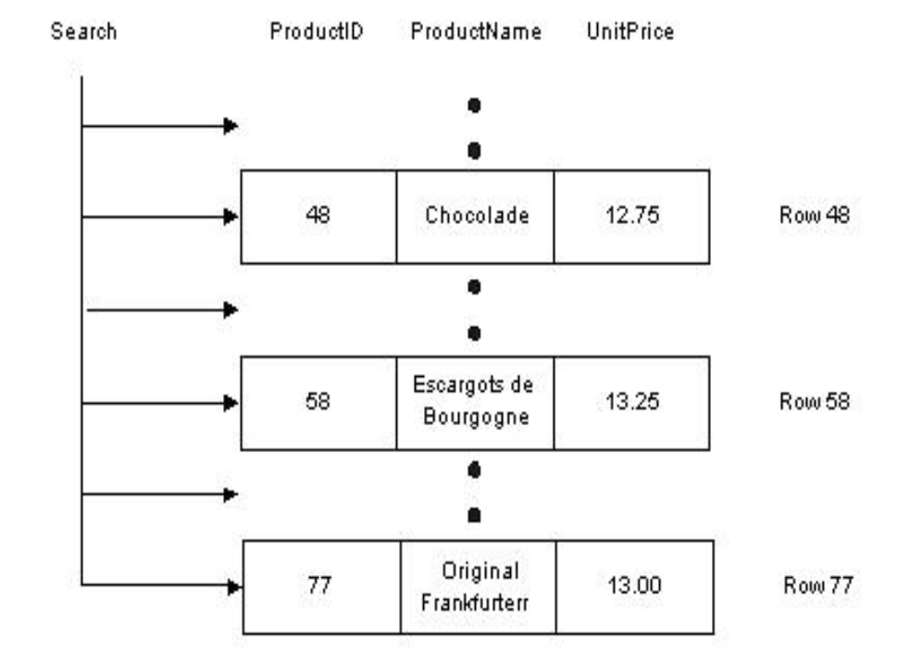

Now imagine if we created an index, just like a book index, on the data in the UnitPrice column. Each index entry would contain a copy of the UnitPrice value for a row, and a reference (just like a page number) to the row where the value originated. SQL will sort these index entries into ascending order. The index will allow the database to quickly narrow in on the three rows to satisfy the query, and avoid scanning every row in the table.
We can create the same index using the following SQL. The command specifies the name of the index (IDX_UnitPrice), the table name (Products), and the column to index (UnitPrice).
CREATE INDEX [IDX_UnitPrice] ON Products (UnitPrice)
How It Works
The database takes the columns specified in a CREATE INDEX command and sorts the values into a special data structure known as a B-tree. A B-tree structure supports fast searches with a minimum amount of disk reads, allowing the database engine to quickly find the starting and stopping points for the query we are using.
Conceptually, we may think of an index as shown in the diagram below. On the left, each index entry contains the index key (UnitPrice). Each entry also includes a reference (which points) to the table rows which share that particular value and from which we can retrieve the required information.
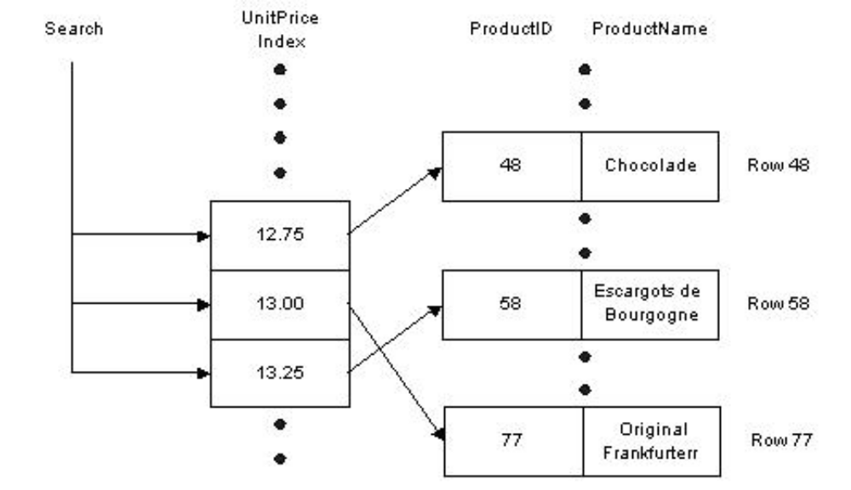

Much like the index in the back of a book helps us to find keywords quickly, so the database is able to quickly narrow the number of records it must examine to a minimum by using the sorted list of UnitPrice values stored in the index. We have avoided a table scan to fetch the query results. Given this sketch of how indexes work, let’s examine some of the scenarios where indexes offer a benefit.
4.9 Summary
- SQL allows users to access data in relational database management systems
- There are three groups of SQL commands viz., DDL, DML and DCL.
- The Data Definition Language (DDL) part of SQL permits database tables to be created or deleted.
- SQL language also includes syntax to update, insert, and delete records. These query and update commands together form the Data Manipulation Language (DML) part of SQL.
- The SQL Data Control Language (DCL) provides security for your database. The DCL consists of the GRANT, REVOKE, COMMIT, and ROLLBACK statements.
- Constraints are a way to limit the kind of data that can be stored in a table.
- Relational databases like SQL Server use indexes to find data quickly when a query is processed.
4.10 Key Words
SQL, DDL, DML, DCL, Constraints, Indexes
4.11 Self Assessment Questions
- What does SQL stand for?
- What SQL statement is used to delete table “Student”?
- How can you insert a new record in table “Department”
- With SQL, how can you insert "GJU" as the "FName" in the "University" table?
- How can you delete a record from table “student” where “RollNo”=GJU501?
- Explain the use of Grant And Revoke Commands?
- What are Transaction Control Language Commands?
- Explain the ways to create a new user?
4.12 References/Suggested Readings
- www.microsoft.com
- Sams Teach Yourself Microsoft SQL Server 2000 in 21 Days by Richard Waymire, Rick Sawtell
- Microsoft SQL Server 7.0 Programming Unleashed by John Papa, et al 20
- Microsoft Sql Server 7.0 Resource Guide by Microsoft Corporation
- http://www.cs.rpi.edu/~temtanay/dbf-fall97/oracle/sql_ddcmd.html 2
Lesson 05: Relational Database Design and Normalization
Structure
5.0 Objectives
5.1 Introduction
5.2 Informal Design Guidelines for Relational Schemas
5.3 Functional Dependencies
5.4 Multivalued Dependencies
5.5 Relational Database
5.6 First Normal Form
5.7 Second Normal Form
5.8 Third Normal Form
5.9 Boyce-Codd Normal Form
5.10 Lossless Join Decomposition’
5.11 Dependency Preservation Decomposition
5.12 Summary
5.13 Key Words
5.14 Self Assessment Questions
5.15 References/Suggested Readings
5.0 Objectives
At the end of this chapter the reader will be able to:
- Describe benefits of relational model
- Describe informal guidelines for relational schema
- Describe update, insertion and deletion anomalies
- Describe Functional Dependencies and its various forms
- Describe fundamentals of normalization
- Describe and distinguish the 1NF, 2NF, 3NF and BCNF normal forms.
- Describe Lossless join and Dependency preserving decomposition

5.1 Introduction
When designing a database, you have to make decisions regarding how best to take some system in the real world and model it in a database. This consists of deciding which tables to create, what columns they will contain, as well as the relationships between the tables. While it would be nice if this process was totally intuitive and obvious, or even better automated, this is simply not the case. A well-designed database takes time and effort to conceive, build and refine.
The benefits of a database that has been designed according to the relational model are numerous. Some of them are:
- Data entry, updates and deletions will be efficient.
- Data retrieval, summarization and reporting will also be efficient.
- Since the database follows a well-formulated model, it behaves predictably.
- Since much of the information is stored in the database rather than in the application, the database is somewhat self-documenting.
- Changes to the database schema are easy to make.

The objective of this chapter is to explain the basic principles behind relational database design and demonstrate how to apply these principles when designing a database.
5.2 Informal Design Guidelines for Relational Schemas
We discuss four informal measures of quality for relation schema design in this section:
- Semantics of the attributes
- Reducing the redundant values in tuples
- Reducing the null values in tuples
- Disallowing the possibility of generating spurious tuples

These measures are not always independent of one another, as we shall see.
5.2.1 Semantics of the attributes
The semantics, specifies how to interpret the attribute values stored in a tuple of the relation-in other words, how the attribute values in a tuple relate to one another. If the conceptual design is done carefully, followed by a systematic mapping into relations, most of the semantics will have been accounted for and the resulting design should have a clear meaning.
Design a relation schema so that it is easy to explain its meaning. Do not combine attributes from multiple entity types and relationship types into a single relation. Intuitively, if a relation schema corresponds to one entity type or one relation
5.2.2 Reducing the redundant values in tuples
Storing the Same information redundantly, that is, in more than one place within a database, can lead to several problems:
Redundant Storage: Some information is stored repeatedly.
Update Anomalies: If one copy of such repeated data is updated, an inconsistency is created unless all copies are similarly updated.
Insertion Anomalies: It may not be possible to store certain information unless some other, unrelated, information is stored as well.
Deletion Anomalies: It may not be possible to delete certain information without losing some other, unrelated, information as well.
Design the base relation schemas so that no insertion, deletion, or modification anomalies are present in the relations. If any anomalies are present, note them clearly and make sure that the programs that update the database will operate correctly.
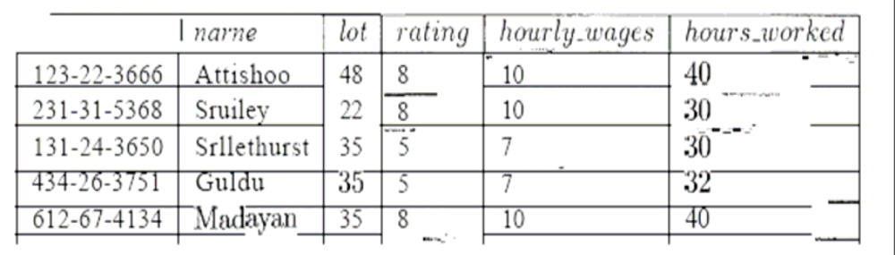
Figure 5.1 An Instance of Hourly_Emps Relation

5.2.3 Reducing the null values in tuples
It is worth considering whether the use of null values can address some of these problems. As we will see in the context of our example, they cannot provide a complete solution, but they can provide some help. In this chapter, we do not discuss the use of null values beyond this one example. Consider the example Hourly_Elmps relation. Clearly, null values cannot help eliminate redundant storage or update anomalies. It appears that they can address insertion and deletion anomalies. For instance, to deal with the insertion anomaly example, we can insert an employee tuple with null values in the hourly wage field. However, null values cannot address all insertion anomalies. For example, we cannot record the hourly wage for a rating unless there is an employee with that rating, because we cannot store a null value in the ssn field, which is a primary key field. Similarly, to deal with the deletion anomaly examnple, we might consider storing a tuple with null values in all fields except rating and hourly_wages if the last tuple with a given rating would otherwise be deleted. However, this solution does not work because it requires the 8871, value to be null, and primary key fields cannot be null. Thus, null values do not provide a general solution to the problems of redundancy, even though they can help in some cases.
Decompositions
Intuitively, redundancy arises when a relational schema forces an association between attributes that is not natural. Functional dependencies can 'be used to identify such situations and suggest refinements to the schema. The essential idea is that many problems arising from redundancy can be addressed by replacing a relation 'with a collection of smaller relations. A. decomposition of a relation schema onsists of replacing the relation schema by two (or more) relation schema that each contain a subset of the attributes of R and together include all attributes in R. Intuitively, we want to store the information in any given instance of R by storing projections of the instance. This section examines the use of decompositions through several examples. we can decompose Hourly_Emps into two relations:
Hourly_Emps2(ssn,name,lot,rating_hours_worked)
Wages (rating, hourly_wages)

The instances of these relations are shown in Figure 5.2 corresponding to instance shown in figure 5.1.
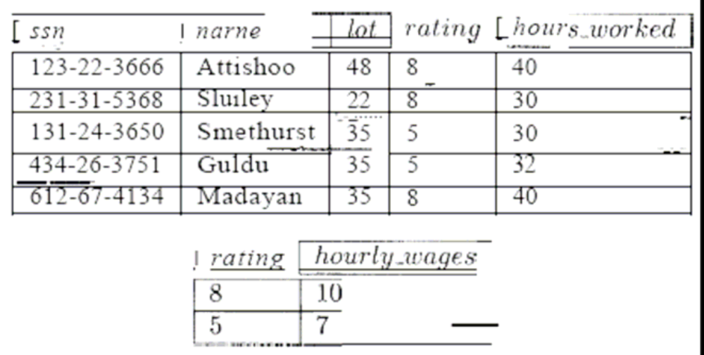
Figure 5.2 Instance of Hourly_Emps2 and Wages

Note that we can easily record the hourly wage for any rating simply by adding a tuple to Wages, even if no employee with that rating appears in the current instance of Hourly_Emps. Changing the wage associated with a rating involves updating a single Wages tuple. This is more efficient than updating several tuples (as in the original design), and it eliminates the potential for inconsistency.
5.2.4 Disallowing the possibility of generating spurious tuples
Design relation schemas so that they can be joined with equality conditions on attributes that are either primary keys or foreign keys in a way that guarantees that no spurious tuples are generated. Avoid relations that contain matching attributes that are not (foreign key, primary key) combinations, because joining on such attributes may produce spurious tuples.
5.3 Functional Dependencies
For our discussion on functional dependencies assume that a relational schema has attributes (A, B, C... Z) and that the whole database is described by a single universal relation called R = (A, B, C, ..., Z). This assumption means that every attribute in the database has a unique name.
A functional dependency is a property of the semantics of the attributes in a relation. The semantics indicate how attributes relate to one another, and specify the functional dependencies between attributes. When a functional dependency is present, the dependency is specified as a constraint between the attributes.
Consider a relation with attributes A and B, where attribute B is functionally dependent on attribute A. If we know the value of A and we examine the relation that holds this dependency, we will find only one value of B in all of the tuples that have a given value of A, at any moment in time. Note however, that for a given value of B there may be several different values of A.
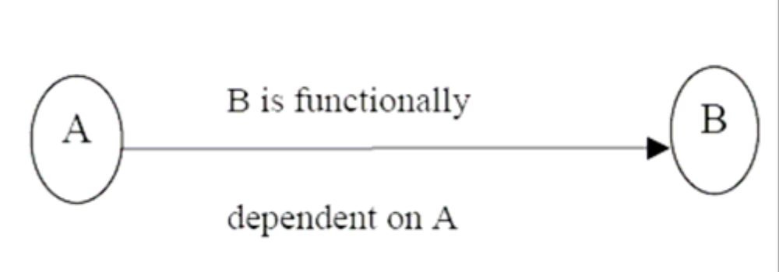
Figure 5.3
In the figure5.3 above, A is the determinant of B and B is the consequent of A.
The determinant of a functional dependency is the attribute or group of attributes on the left-hand side of the arrow in the functional dependency. The consequent of a fd is the attribute or group of attributes on the right-hand side of the arrow.
Identifying Functional Dependencies
Now let us consider the following Relational schema shown in figure 5.4.
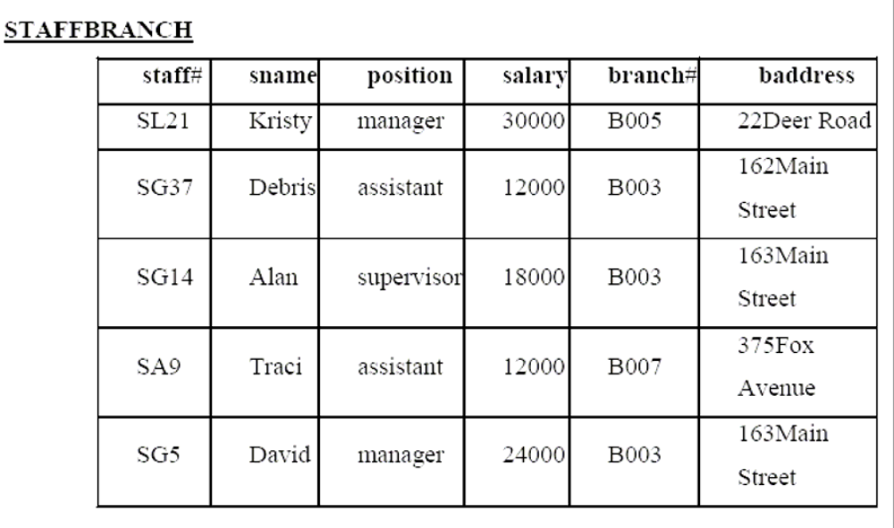
Figure 5.4 Relational Schema
The functional dependency staff# → position clearly holds on this relation instance. However, the reverse functional dependency position → staff# clearly does not hold.
The relationship between staff# and position is 1:1 – for each staff member there is only one position. On the other hand, the relationship between position and staff# is 1:M – there are several staff numbers associated with a given position.
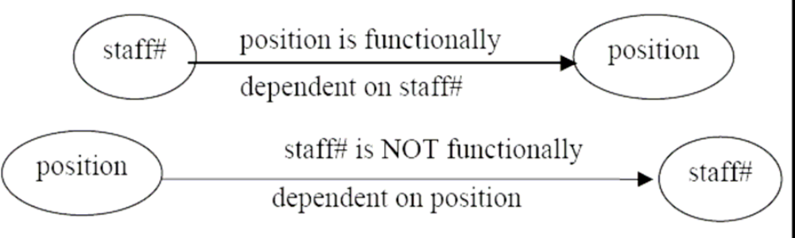
Figure 5.5
For the purposes of normalization we are interested in identifying functional dependencies between attributes of a relation that have a 1:1 relationship.
When identifying Fds between attributes in a relation it is important to distinguish clearly between the values held by an attribute at a given point in time and the set of all possible values that an attributes may hold at different times.
In other words, a functional dependency is a property of a relational schema (its intension) and not a property of a particular instance of the schema (extension).
The reason that we need to identify Fds that hold for all possible values for attributes of a relation is that these represent the types of integrity constraints that we need to identify. Such constraints indicate the limitations on the values that a relation can legitimately assume. In other words, they identify the legal instances which are possible.
Let’s identify the functional dependencies that hold using the relation schema STAFFBRANCH
In order to identify the time invariant Fds, we need to clearly understand the semantics of the various attributes in each of the relation schemas in question.
For example, if we know that a staff member’s position and the branch at which they are located determines their salary. There is no way of knowing this constraint unless you are familiar with the enterprise, but this is what the requirements analysis phase and the conceptual design phase are all about!
staff# → sname, position, salary, branch#, baddress
branch# → baddress
baddress → branch#
branch#, position → salary
baddress, position → salary

5.3.1 Trivial Functional Dependencies
As well as identifying Fds which hold for all possible values of the attributes involved in the fd, we also want to ignore trivial functional dependencies. A functional dependency is trivial if, the consequent is a subset of the determinant. In other words, it is impossible for it not to be satisfied.
Example: Using the relation instances on page 6, the trivial dependencies include:
{ staff#, sname} → sname
{ staff#, sname} → staff#

Although trivial Fds are valid, they offer no additional information about integrity constraints for the relation. As far as normalization is concerned, trivial Fds are ignored.
5.3.2 Inference Rules for Functional Dependencies
We’ll denote as F, the set of functional dependencies that are specified on a relational schema R.
Typically, the schema designer specifies the Fds that are semantically obvious; usually however, numerous other Fds hold in all legal relation instances that satisfy the dependencies in F.
These additional Fds that hold are those Fds which can be inferred or deduced from the Fds in F.
The set of all functional dependencies implied by a set of functional dependencies F is called the closure of F and is denoted F+.
The notation: F X → Y denotes that the functional dependency X → Y is implied by the set of Fds F.
Formally, F+ ≡ {X → Y | F X → Y}
A set of inference rules is required to infer the set of Fds in F+.
For example, if I tell you that Kristi is older than Debi and that Debi is older than Traci, you are able to infer that Kristi is older than Traci. How did you make this inference? Without thinking about it or maybe knowing about it, you utilized a transitivity rule to allow you to make this inference. The set of all Fds that are implied by a given set S of Fds is called the closure of S, written S+. Clearly we need an algorithm that will allow us to compute S+ from S. You know the first attack on this problem appeared in a paper by Armstrong which gives a set of inference rules. The following are the six well-known inference rules that apply to functional dependencies.
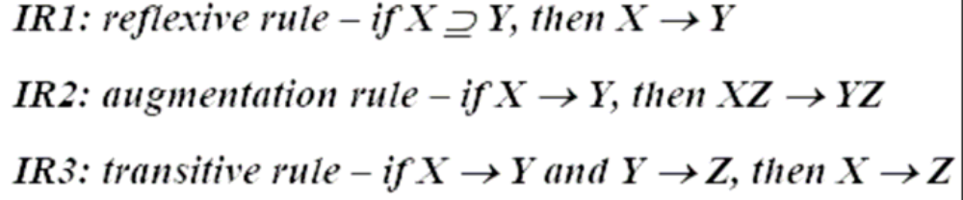
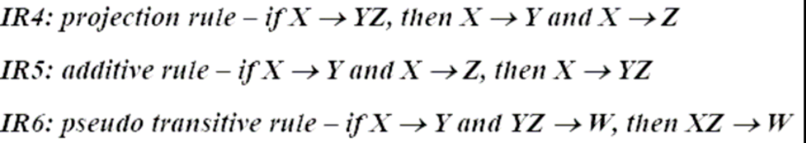
The first three of these rules (IR1-IR3) are known as Armstrong’s Axioms and constitute a necessary and sufficient set of inference rules for generating the closure of a set of functional dependencies. These rules can be stated in a variety of equivalent ways. Each of these rules can be directly proved from the definition of functional dependency. Moreover the rules are complete, in the sense that, given a set S of Fds, all Fds implied by S can be derived from S using the rules. The other rules are derived from these three rules.
Given R = (A,B,C,D,E,F,G,H, I, J) and
F = {AB → E, AG → J, BE → I, E → G, GI → H}
Does F AB → GH?
Proof
- AB → E, given in F
- AB → AB, reflexive rule IR1
- AB → B, projective rule IR4 from step 2
- AB → BE, additive rule IR5 from steps 1 and 3
- BE → I, given in F
- AB → I, transitive rule IR3 from steps 4 and 5
- E → G, given in F
- AB → G, transitive rule IR3 from steps 1 and 7
- AB → GI, additive rule IR5 from steps 6 and 8
- GI → H, given in F
- AB → H, transitive rule IR3 from steps 9 and 10
- AB → GH, additive rule IR5 from steps 8 and 11 – proven
Irreducible sets of dependencies
Let S1 and S2 be two sets of Fds, if every FD implied by S1 is implied by S2- i.e.; if S1+ is a subset of S2+-we say that S2 is a cover for S1+(Cover here means equivalent set). What this means is that if the DBMS enforces the Fds in S2, then it will automatically be enforcing the Fds in S1.
Next…..

Next if S2 is a cover for S1 and S1 is a cover for S2- i.e.; if S1+=S2+ -we say that S1 and S2 are equivalent, clearly, if s1 and S2 are equivalent, then if the DBMS enforces the Fds in S2 it will automatically be enforcing the Fds in S1, And vice versa.
Now we define a set of Fds to be irreducible( Usually called minimal in the literature) if and only if it satisfies the following three properties
  - The right hand side (the dependent) of every Fds in S involves just one attribute (that is, it is singleton set)
  - The left hand side (determinant) of every in S is irreducible in turn-meaning that no attribute can be discarded from the determinant without changing the closure S+(that is, without converting S into some set not equivalent to S). We will say that such an Fd is left irreducible.
  - No Fd in S can be discarded from S without changing the closure S+(That is, without converting s into some set not equivalent to S)

Now we will work out the things in detail.
Relation R {A,B,C,D,E,F} satisfies the following Fds
AB → C
C → A
BC → D
ACD → B
BE → C
CE → FA
CF → VD
D → EF

Find an irreducible equivalent for this set of Fds?
Puzzled! The solution is simple. Let us find the solution for the above.
- AB → C
- C → A
- BC → D
- ACD → B
- BE → C
- CE → A
- CE → F
- CF → B
- CF → D
- D → E
- D → F
Now:
- 2 implies 6, so we can drop 6
- 8 implies CF → BC (By augmentation), by which 3 implies CF → D (By Transitivity), so we can drop 10.
- 8 implies ACF → AB (By augmentation), and 11 implies ACD → ACF (By augmentation), and so ACD → AB (By Transitivity), and so ACD → B(By Decomposition), so we can drop 4
No further reductions are possible, and so we are left with the following irreducible set:
AB → C
C → A
BC → D
BE → C
CE → F
CF → B
D → E
D → F
Alternatively:
• 2 implies CD → ACD (By Composition), which with 4 implies CD → BE (By Transitivity), so we can replace 4 CD → B
• 2 implies 6, so we can drop 6(as before)
2 and 10 implies CF → AD (By composition), which implies CF → ADC (By Augmentation), which with (the original) 4 implies CF → B(By Transitivity), So we can drop 8.
No further reductions are possible, and so we are left with following irreducible set: AB → C
C → A
BC → D
CD → B
BE → C
CE → F
CF → D
D → E
D → F
Observe, therefore, that there are two distinct irreducible equivalence for the original set of Fds.
5.4 Multivalued Dependencies
The multivalued dependency relates to the problem when more than one multivalued attributes exist. Consider the following relation that represents an entity employee that has one mutlivalued attribute proj:
emp (e#, dept, salary, proj)
We have so far considered normalization based on functional dependencies; dependencies that apply only to single-valued facts. For example, e#→dept implies only one dept value for each value of e#. Not all information in a database is single-valued, for example, proj in an employee relation may be the list of all projects that the employee is currently working on. Although e# determines the list of all projects that an employee is working on e#→proj, is not a functional dependency.
So far we have dealt with multivalued facts about an entity by having a separate relation for that multivalue attribute and then inserting a tuple for each value of that fact. This resulted in composite keys since the multivalued fact must form part of the key. In none of our examples so far have we dealt with an entity having more than one multivalued attribute in one relation. We do so now.
The fourth and fifth normal forms deal with multivalued dependencies. The 4th and 5th normal forms are discussed in the lecture that deals with normalization. We discuss the following example to illustrate the concept of multivalued dependency.
programmer (emp_name, qualifications, languages)
The above relation includes two multivalued attributes of entity programmer; qualifications and languages. There are no functional dependencies.
The attributes qualifications and languages are assumed independent of each other. If we were to consider qualifications and languages separate entities, we would have two relationships (one between employees and qualifications and the other between employees and programming languages). Both the above relationships are many-to-many i.e. one programmer could have several qualifications and may know several programming languages. Also one qualification may be obtained by several programmers and one programming language may be known to many programmers.
Suppose a programmer has several qualifications (B.Sc, Dip. Comp. Sc, etc) and is proficient in several programming languages; how should this information be represented? There are several possibilities.

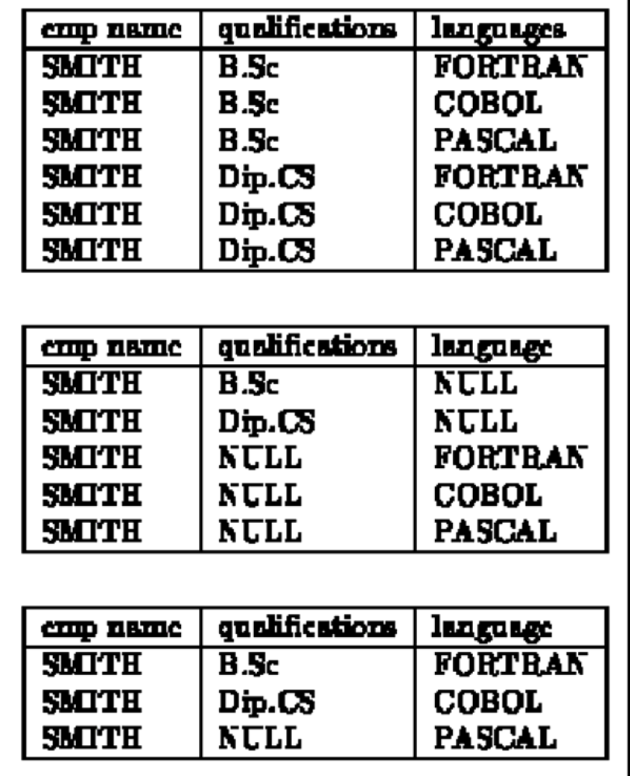
Figure 5.6
Other variations are possible (we remind the reader that there is no relationship between qualifications and programming languages). All these variations have some disadvantages. If the information is repeated we face the same problems of repeated information and anomalies as we did when second or third normal form conditions are violated. If there is no repetition, there are still some difficulties with search, insertions and deletions. For example, the role of NULL values in the above relations is confusing. Also the candidate key in the above relations is (emp name, qualifications, language) and existential integrity requires that no NULLs be specified. These problems may be overcome by decomposing a relation like the one above(Figure 5.6) as follows:
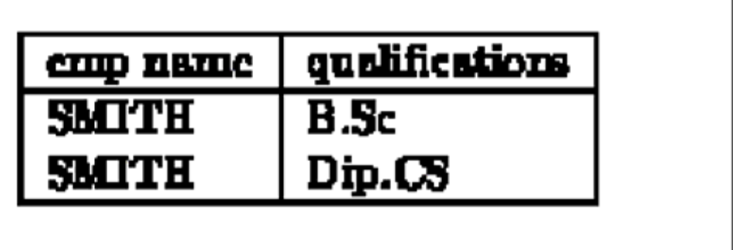
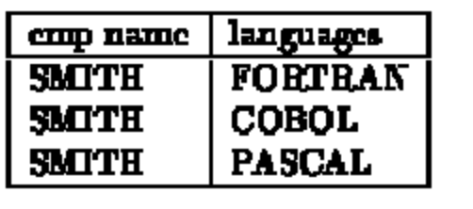
Figure 5.7
The basis of the above decomposition is the concept of multivalued dependency (MVD). Functional dependency A→B relates one value of A to one value of B while multivalued dependency A→B defines a relationship in which a set of values of attribute B are determined by a single value of A.
The concept of multivalued dependencies was developed to provide a basis for decomposition of relations like the one above. Therefore if a relation like enrolment(sno, subject#) has a relationship between sno and subject# in which sno uniquely determines the values of subject#, the dependence of subject# on sno is called a trivial MVD since the relation enrolment cannot be decomposed any further. More formally, a MVD X→Y is called trivial MVD if either Y is a subset of X or X and Y together form the relation R. The MVD is trivial since it results in no constraints being placed on the relation. Therefore a relation having non-trivial MVDs must have at least three attributes; two of them multivalued. Non-trivial MVDs result in the relation having some constraints on it since all possible combinations of the multivalue attributes are then required to be in the relation.
Let us now define the concept of multivalued dependency.
The multivalued dependency X→Y is said to hold for a relation R(X, Y, Z) if for a given set of value (set of values if X is more than one attribute) for attributes X, there is a set of (zero or more) associated values for the set of attributes Y and the Y values depend only on X values and have no dependence on the set of attributes Z.
In the example above, if there was some dependence between the attributes qualifications and language, for example perhaps, the language was related to the qualifications (perhaps the qualification was a training certificate in a particular language), then the relation would not have MVD and could not be decomposed into two relations as above. The theory of multivalued dependencies in very similar to that for functional dependencies. Given D a set of MVDs, we may find D⁺, the closure of D using a set of axioms. We do not discuss the axioms here.
5.5 Relational Database
Relational database tables, whether they are derived from ER or UML models, sometimes suffer from some rather serious problems in terms of
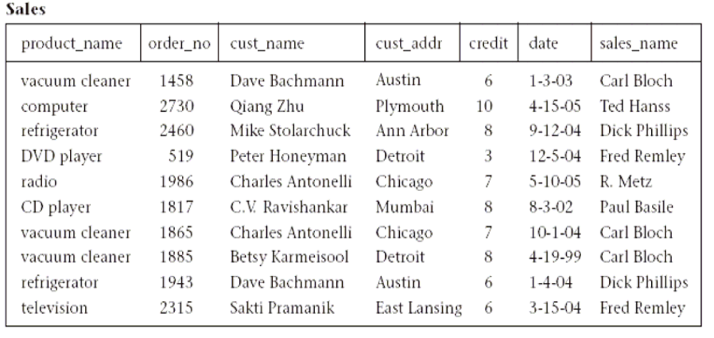
Figure 5.8 Single table database
performance, integrity and maintainability. For example, when the entire database is defined as a single large table, it can result in a large amount of redundant data and lengthy searches for just a small number of target rows. It can also result in long and expensive updates, and deletions in particular can result in the elimination of useful data as an unwanted side effect.
Such a situation is shown in Figure 5.8, where products, salespersons, customers, and orders are all stored in a single table called Sales. In this table, we see that certain product and customer information is stored redundantly, wasting storage space. Certain queries, such as “Which customers ordered vacuum cleaners last month?” would require a search of the entire table. Also, updates such as changing the address of the customer Dave Bachmann would require changing many rows. Finally, deleting an order by a valued customer such as Qiang Zhu (who bought an expensive computer), if that is his only outstanding order, deletes the only copy of his address and credit rating as a side effect. Such information may be difficult (or sometimes impossible) to recover. These problems also occur for situations in which the database has already been set up as a collection of many tables, but some of the tables are still too large.
If we had a method of breaking up such a large table into smaller tables so that these types of problems would be eliminated, the database would be much more efficient and reliable. Classes of relational database schemes or table definitions, called normal forms, are commonly used to accomplish this goal. The creation of a normal form database table is called normalization. Normalization is accomplished by analyzing the interdependencies among individual attributes associated with those tables and taking projections (subsets of columns) of larger tables to form smaller ones.
Normalization is a formal process for determining which fields belong in which tables in a relational database. Normalization follows a set of rules worked out at the time relational databases were born. A normalized relational database provides several benefits:
- Elimination of redundant data storage.
- Close modeling of real world entities, processes, and their relationships.
- Structuring of data so that the model is flexible.
- Normalization ensures that you get the benefits relational databases offer. Time spent learning about normalization will begin paying for itself immediately.

Let us first review the basic normal forms, which have been well established in the relational database literature and in practice.
5.6 First Normal Form
Definition. A table is in first normal form (1NF) if and only if all columns contain only atomic values, that is, each column can have only one value for each row in the table.
Relational database tables, such as the Sales table illustrated in Figure 5.9, have only atomic values for each row and for each column. Such tables are considered to be in first normal form, the most basic level of normalized tables.
To better understand the definition for 1NF, it helps to know the difference between a domain, an attribute, and a column. A domain is the set of all possible values for a particular type of attribute, but may be used for more than one attribute. For example, the domain of people’s names is the underlying set of all possible names that could be used for either customer-name or salesperson-name in the database table in Figure 5.8. Each column in a relational table represents a single attribute, but in some cases more than one column may refer to different attributes from the same domain. When this occurs, the table is still in 1NF because the values in the table are still atomic. In fact, standard SQL assumes only atomic values and a relational table is by default in 1NF.
5.6.1 Superkeys, Candidate Keys, and Primary Keys
A table in 1NF often suffers from data duplication, update performance, and update integrity problems, as noted above. To understand these issues better, however, we must define the concept of a key in the context of normalized tables. A superkey is a set of one or more attributes, which, when taken collectively, allows us to identify uniquely an entity or table. Any subset of the attributes of a superkey that is also a superkey, and not reducible to another superkey, is called a candidate key. A primary key is selected arbitrarily from the set of candidate keys to be used in an index for that table.
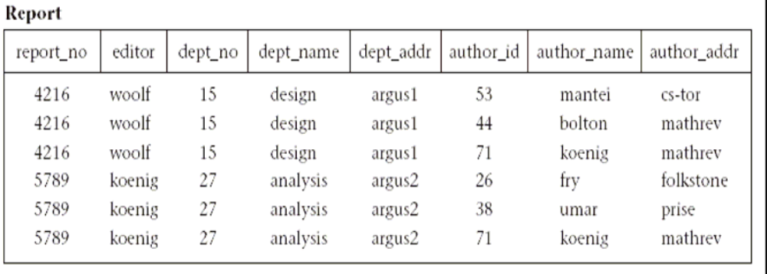
Figure 5.9 Report table

As an example, in Figure 5.9 a composite of all the attributes of the table forms a superkey because duplicate rows are not allowed in the relational model. Thus, a trivial superkey is formed from the composite of all attributes in a table. Assuming that each department address (dept_addr) in this table is single valued, we can conclude that the composite of all attributes except dept_addr is also a superkey. Looking at smaller and smaller composites of attributes and making realistic assumptions about which attributes are single valued, we find that the composite (report_no, author_id) uniquely determines all the other attributes in the table and is therefore a superkey. However, neither report_no nor author_id alone can determine a row uniquely, and the composite of these two attributes cannot be reduced and still be a superkey. Thus, the composite (report_no, author_id) becomes a candidate key. Since it is the only candidate key in this table, it also becomes the primary key.
A table can have more than one candidate key. If, for example, in Figure 5.9, we had an additional column for author_ssn, and the composite of report_no and author_ssn uniquely determine all the other attributes of the table, then both (report_no, author_id) and (report_no, author_ssn) would be candidate keys. The primary key would then be an arbitrary choice between these two candidate keys.
5.7 Second Normal Form
To explain the concept of second normal form (2NF) and higher, we introduce the concept of functional dependence. The property of one or more attributes that uniquely determine the value of one or more other attributes is called functional dependence. Given a table (R), a set of attributes (B) is functionally dependent on another set of attributes (A) if, at each instant of time, each A value is associated with only one B value. Such a functional dependence is denoted by A -> B. In the preceding example from Figure 5.9, let us assume we are given the following functional dependencies for the table report:
report: report_no -> editor, dept_no
dept_no -> dept_name, dept_addr
author_id -> author_name, author_addr

Definition. A table is in second normal form (2NF) if and only if it is in 1NF and every nonkey attribute is fully dependent on the primary key. An attribute is fully dependent on the primary key if it is on the right side of an FD for which the left side is either the primary key itself or something that can be derived from the primary key using the transitivity of FDs.
An example of a transitive FD in report is the following:
report_no -> dept_no
dept_no -> dept_name
Therefore we can derive the FD (report_no -> dept_name), since dept_name is transitively dependent on report_no.
Continuing our example, the composite key in Figure 5.9, (report_no, author_id), is the only candidate key and is therefore the primary key. However, there exists one FD (dept_no -> dept_name, dept_addr) that has no component of the primary key on the left side, and two FDs (report_no -> editor, dept_no and author_id -> author_name, author_addr) that contain one component of the primary key on the left side, but not both components. As such, report does not satisfy the condition for 2NF for any of the FDs.
Consider the disadvantages of 1NF in table report. Report_no, editor, and dept_no are duplicated for each author of the report. Therefore, if the editor of the report changes, for example, several rows must be updated. This is known as the update anomaly, and it represents a potential degradation of performance due to the redundant updating. If a new editor is to be added to the table, it can only be done if the new editor is editing a report: both the report number and editor number must be known to add a row to the table, because you cannot have a primary key with a null value in most relational databases. This is known as the insert anomaly. Finally, if a report is withdrawn, all rows associated with that report must be deleted. This has the side effect of deleting the information that associates an author_id with author_name and author_addr. Deletion side effects of this nature are known as delete anomalies. They represent a potential loss of integrity, because the only way the data can be restored is to find the data somewhere outside the database and insert it back into the database. All three of these anomalies represent problems to database designers, but the delete anomaly is by far the most serious because you might lose data that cannot be recovered. These disadvantages can be overcome by transforming the 1NF table into two or more 2NF tables by using the projection operator on the subset of the attributes of the 1NF table. In this example we project report over report_no, editor, dept_no, dept_name, and dept_addr to form report1; and project report over author_id, author_name, and author_addr to form report2; and finally project report over report_no and author_id to form report3. The projection of report into three smaller tables has preserved the FDs and the association between report_no and author_no that was important in the original table. Data for the three tables is shown in Figure 5.10. The FDs for these 2NF tables are:
report1: report_no -> editor, dept_no
dept_no -> dept_name, dept_addr
report2: author_id -> author_name, author_addr
report3: report_no, author_id is a candidate key (no FDs)
We now have three tables that satisfy the conditions for 2NF, and we have eliminated the worst problems of 1NF, especially integrity (the delete anomaly). First, editor, dept_no, dept_name, and dept_addr are no longer duplicated for each author of a report. Second, an editor change results in only an update to one row for report1. And third, the most important, the deletion of the report does not have the side effect of deleting the author information.
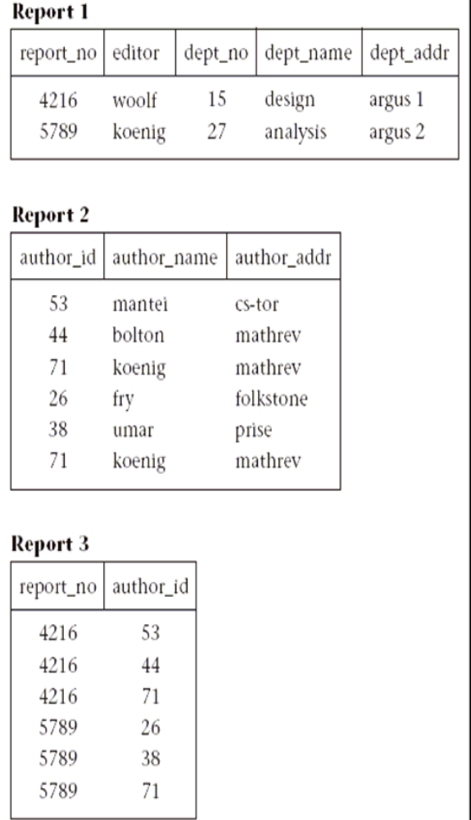
Figure 5.10 2NF tables

Not all performance degradation is eliminated, however; report_no is still duplicated for each author, and deletion of a report requires updates to two tables (report1 and report3) instead of one. However, these are minor problems compared to those in the 1NF table report. Note that these three report tables in 2NF could have been generated directly from an ER (or UML) diagram that equivalently modeled this situation with entities Author and Report and a many-to-many relationship between them.
5.8 Third Normal Form
The 2NF tables we established in the previous section represent a significant improvement over 1NF tables. However, they still suffer from
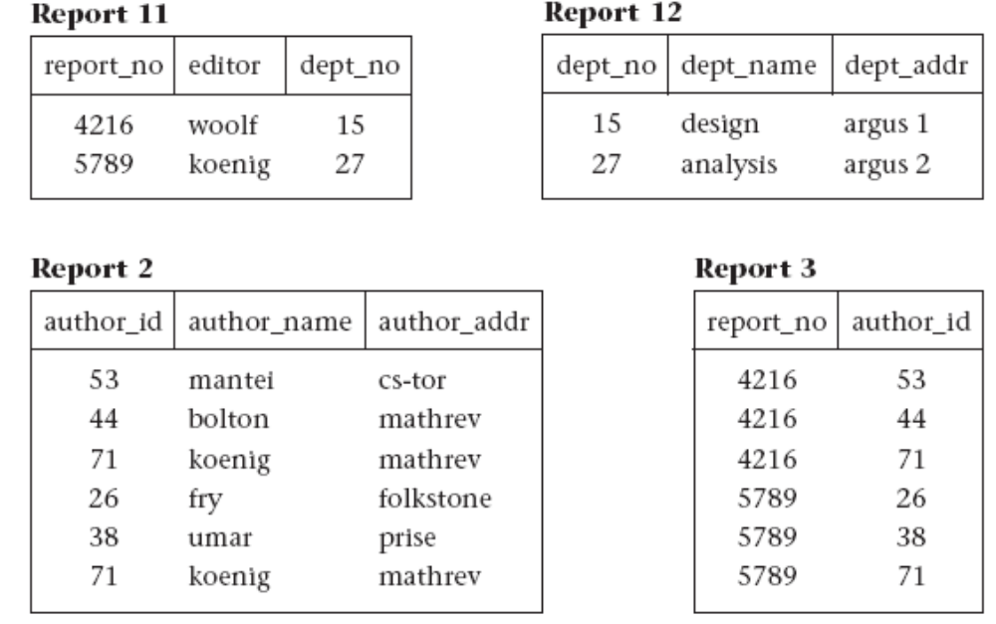
Figure 5.11 3NF tables

the same types of anomalies as the 1NF tables although for different reasons associated with transitive dependencies. If a transitive (functional) dependency exists in a table, it means that two separate facts are represented in that table, one fact for each functional dependency involving a different left side. For example, if we delete a report from the database, which involves deleting the appropriate rows from report1 and report3 (see Figure 5.10), we have the side effect of deleting the association between dept_no, dept_name, and dept_addr as well. If we could project table report1 over report_no, editor, and dept_no to form table report11, and project report1 over dept_no, dept_name, and dept_addr to form table report12, we could eliminate this problem. Example tables for report11 and report12 are shown in Figure 5.11.

Definition. A table is in third normal form (3NF) if and only if for every nontrivial functional dependency X->A, where X and A are either simple or composite attributes, one of two conditions must hold. Either attribute X is a superkey, or attribute A is a member of a candidate key. If attribute A is a member of a candidate key, A is called a prime attribute. Note: a trivial FD is of the form YZ->Z. In the preceding example, after projecting report1 into report11 and report12 to eliminate the transitive dependency report_no -> dept_no -> dept_name, dept_addr, we have the following 3NF tables and their functional dependencies (and example data in Figure 5.11):
report11: report_no -> editor, dept_no
report12: dept_no -> dept_name, dept_addr
report2: author_id -> author_name, author_addr
report3: report_no, author_id is a candidate key (no FDs)
5.9 Boyce-Codd Normal Form
3NF, which eliminates most of the anomalies known in databases today, is the most common standard for normalization in commercial databases and CASE tools. The few remaining anomalies can be eliminated by the Boyce-Codd normal form (BCNF). BCNF is considered to be a strong variation of 3NF.
Definition. A table R is in Boyce-Codd normal form (BCNF) if for every nontrivial FD X->A, X is a superkey.
BCNF is a stronger form of normalization than 3NF because it eliminates the second condition for 3NF, which allowed the right side of the FD to be a prime attribute. Thus, every left side of an FD in a table must be a superkey. Every table that is BCNF is also 3NF, 2NF, and 1NF, by the previous definitions.
The following example shows a 3NF table that is not BCNF. Such tables have delete anomalies similar to those in the lower normal forms.
Assertion 1. For a given team, each employee is directed by only one leader. A team may be directed by more than one leader.
emp_name, team_name -> leader_name
Assertion 2. Each leader directs only one team.
leader_name -> team_name
This table is 3NF with a composite candidate key emp_id, team_id:
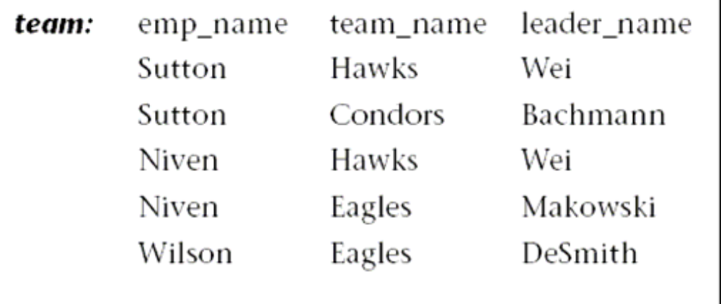
The team table has the following delete anomaly: if Sutton drops out of the Condors team, then we have no record of Bachmann leading the Condors team. As shown by Date [1999], this type of anomaly cannot have a lossless decomposition and preserve all FDs. A lossless decomposition requires that when you decompose the table into two smaller tables by projecting the original table over two overlapping subsets of the scheme, the natural join of those subset tables must result in the original table without any extra unwanted rows. The simplest way to avoid the delete anomaly for this kind of situation is to create a separate table for each of the two assertions. These two tables are partially redundant, enough so to avoid the delete anomaly. This decomposition is lossless (trivially) and preserves functional dependencies, but it also degrades update performance due to redundancy, and necessitates additional storage space. The trade-off is often worth it because the delete anomaly is avoided.

5.10 Lossless-Join Decomposition
In this chapter so far we have normalized a number of relations by decomposing them. We decomposed a relation intuitively. We need a better basis for deciding decompositions since intuition may not always be correct. We illustrate how a careless decomposition may lead to problems including loss of information.
Consider the following relation
enrol (sno, cno, date-enrolled, room-No., instructor)
Suppose we decompose the above relation into two relations enrol1 and enrol2 as follows
enrol1 (sno, cno, date-enrolled)
enrol2 (date-enrolled, room-No., instructor)
There are problems with this decomposition but we wish to focus on one aspect at the moment. Let an instance of the relation enrol be
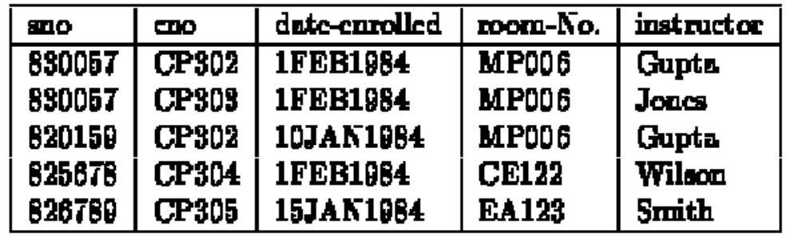
and let the decomposed relations enrol1 and enrol2 be:
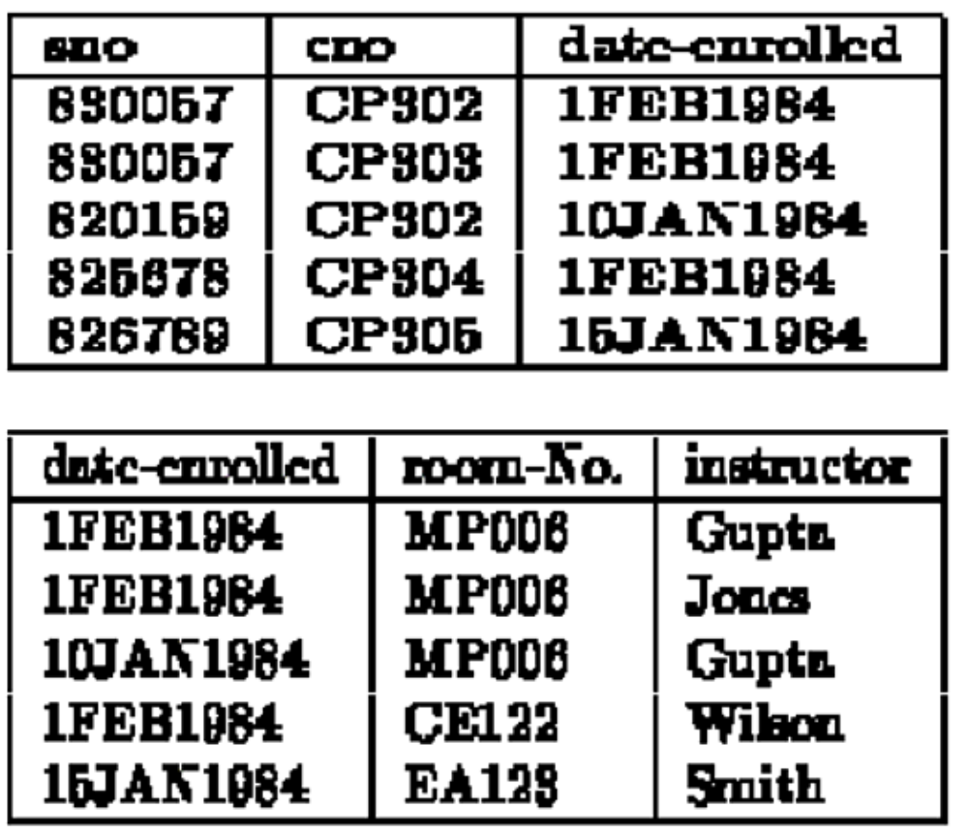
All the information that was in the relation enrol appears to be still available in enrol1 and enrol2 but this is not so. Suppose, we wanted to retrieve the student numbers of all students taking a course from Wilson, we would need to join enrol1 and enrol2. The join would have 11 tuples as follows:
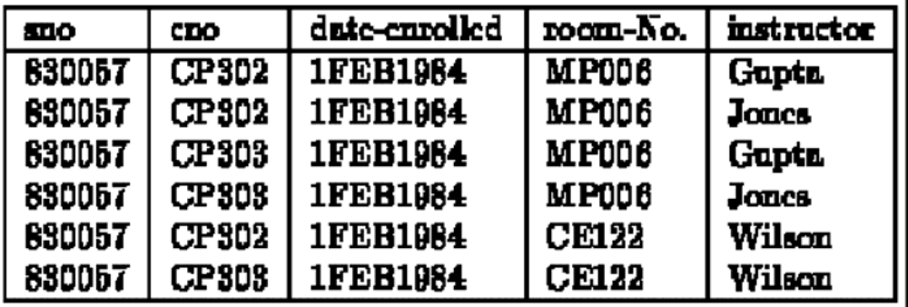
(add further tuples ...)
The join contains a number of spurious tuples that were not in the original relation Enrol. Because of these additional tuples, we have lost the information about which students take courses from WILSON. (Yes, we have more tuples but less information because we are unable to say with certainty who is taking courses from WILSON). Such decompositions are called lossy decompositions. A nonloss or lossless decomposition is that which guarantees that the join will result in exactly the same relation as was decomposed. One might think that there might be other ways of recovering the original relation from the decomposed relations but, sadly, no other operators can recover the original relation if the join does not (why?).
We need to analyse why some decompositions are lossy. The common attribute in above decompositions was Date-enrolled. The common attribute is the glue that gives us the ability to find the relationships between different relations by joining the relations together. If the common attribute is not unique, the relationship information is not preserved. If each tuple had a unique value of Date-enrolled, the problem of losing information would not have existed. The problem arises because several enrolments may take place on the same date.
A decomposition of a relation R into relations R₁, R₂,…..,R_{n} is called a lossless-join decomposition (with respect to FDs F) if the relation R is always the natural join of the relations R₁, R₂,…..,R_{n} . It should be noted that natural join is the only way to recover the relation from the decomposed relations. There is no other set of operators that can recover the relation if the join cannot. Furthermore, it should be noted when the decomposed relations R₁, R₂,…..,R_{n} are obtained by projecting on the relation R, for example R₁ by projection Π_{1( R)} , the relation R₁ may not always be precisely equal to the projection since the relation R₁ might have additional tuples called the dangling tuples. Explain ...
It is not difficult to test whether a given decomposition is lossless-join given a set of functional dependencies F. We consider the simple case of a relation R being decomposed into R₁ and R₂ . If the decomposition is lossless-join, then one of the following two conditions must hold
R_{1 ∩ R2 →} R_{1 - R2}
R_{1 ∩ R2 →} R_{2 – R1}
5.11 Dependency Preservation Decomposition
It is clear that decomposition must be lossless so that we do not lose any information from the relation that is decomposed. Dependency preservation is another important requirement since a dependency is a constraint on the database and if x→y holds than we know that the two (sets) attributes are closely related and it would be useful if both attributes appeared in the same relation so that the dependency can be checked easily.
Let us consider a relation R(A, B, C, D) that has the dependencies F that include the following:
A→ B
A →C
etc
If we decompose the above relation into R1(A, B) and R2(B, C, D) the dependency A →C cannot be checked (or preserved) by looking at only one relation. It is desirable that decompositions be such that each dependency in F may be checked by looking at only one relation and that no joins need be computed for checking dependencies. In some cases, it may not be possible to preserve each and every dependency in F but as long as the dependencies that are preserved are equivalent to F, it should be sufficient.
Let F be the dependencies on a relation R which is decomposed in relations R₁, R₂,…..,R_{n}.
We can partition the dependencies given by F such that F₁,F₂,…..F_{N}. F_{N} are dependencies that only involve attributes from relations R₁, R₂,…..,R_{n} respectively. If the union of dependencies F_{i} imply all the dependencies in F, then we say that the decomposition has preserved dependencies, otherwise not.
If the decomposition does not preserve the dependencies F, then the decomposed relations may contain relations that do not satisfy F or the updates to the decomposed relations may require a join to check that the constraints implied by the dependencies still hold.
Consider the following relation
sub(sno, instructor, office)
We may wish to decompose the above relation to remove the transitive dependency of office on sno. A possible decomposition is
S1(sno, instructor)
S2(sno, office)
The relations are now in 3NF but the dependency instructor→office cannot be verified by looking at one relation; a join of S1 and S2 is needed. In the above decomposition, it is quite possible to have more than one office number for one instructor although the functional dependency instructor→office does not allow it.
5.12 Summary
- While designing a relational schema semantics of attributes, reducing the redundant values in a tuple, reducing null valuesin tuples and avoiding generation of spurious tuples are some of the issues that need to be taken care of.
- Design the base relation schemas so that no insertion, deletion, or modification anomalies are present in the relations.
- Redundancy arises when a relational schema forces an association between attributes that is not natural. Functional dependencies can 'be used to identify such situations and suggest refinements to the schema.
- A functional dependency is a property of the semantics of the attributes in a relation. The semantics indicate how attributes relate to one another, and specify the functional dependencies between attributes.
- A table is in first normal form (1NF) if and only if all columns contain only atomic values, that is, each column can have only one value for each row in the table.
- A superkey is a set of one or more attributes, which, when taken collectively, allows us to identify uniquely an entity or table.
- Any subset of the attributes of a superkey that is also a superkey, and not reducible to another superkey, is called a candidate key.
- A primary key is selected arbitrarily from the set of candidate keys to be used in an index for that table.
- A table R is in Boyce-Codd normal form (BCNF) if for every nontrivial FD X->A, X is a superkey.
5.13 Key Words
Database Design, Modification Anomalies, Decomposition, Functional Dependency, Normalisation, First Normal Form, Second Normal Form, Third Normal Form, BCNF, Lossless Join, Dependency Preservation, Super key, Candidate Key, Primary Key
5.14 Self Assessment Questions
- What are the various guidelines that need to be taken care of while designing a relational schema?
- Describe update, insert and delete anomalies with the help of examples.
- Define functional dependencies?
- Explain the inference rules?
- Explain the concept of multi valued dependency?
- What does the term unnormalized relation refer to? How did the normal forms develop historically?
- Write down all the rules for normalization and explain with example.
- Define first, second, and third normal forms when only primary keys are considered. How do the general definitions of 2NF and 3NF, which consider all keys of a relation, differ from those that consider only primary keys?
5.15 References/Suggested Readings
  - http://www.microsoft-accesssolutions.co.uk
  - Date, C, J, Introduction to Database Systems, 7th edition
  - Leon, Alexis and Leon, Mathews, Database Management Systems, LeonTECHWorld.

